Antimicrobial resistance:
What does medicine quality have to do with it?

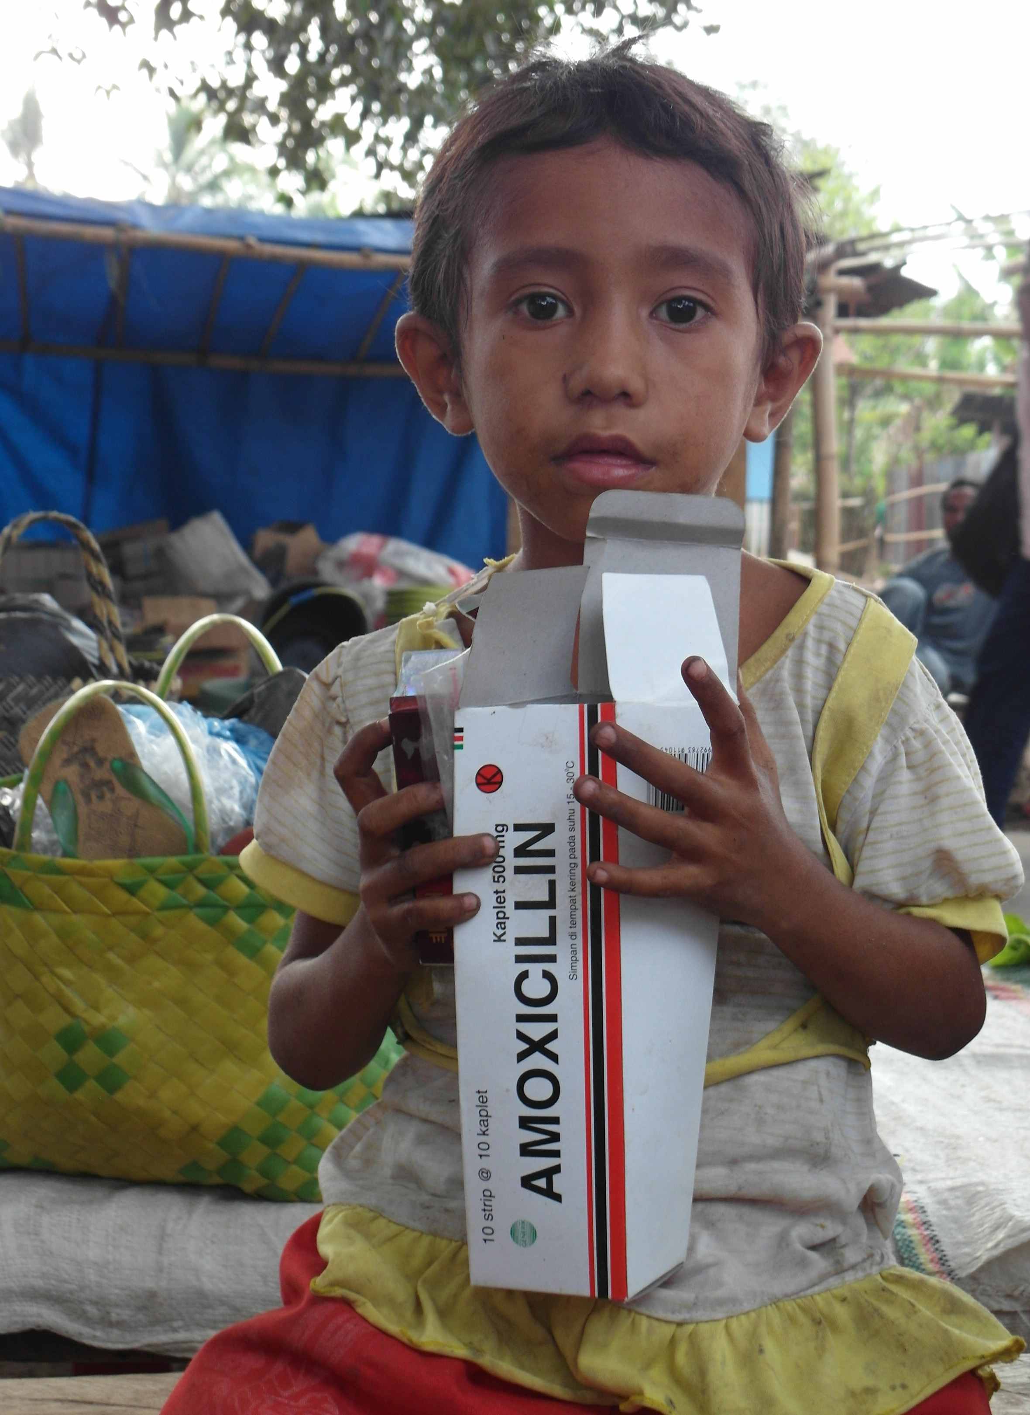
Medicine seller in Eastern Indonesia. Photo: Elizabeth Pisani

Paper prepared by Dr. Elizabeth Pisani,
Visiting Senior Research Fellow, Policy Institute, King's College London
and Director of Ternyata Ltd.
for the Review on Antimicrobial Resistance.
September 22, 2015.

Table of Contents
Table of Contents 2
Introduction 3
Methods 4
Poor quality medicines: what are they? 4
The contribution of poor quality medicine to AMR 7
Reduced delivery of API 8
Increased concentrations of pathogens 9
Unprotected partner medicines 9
Physician behaviour 10
Quantifying problem of poor quality medicine and its contribution to resistance 12
What proportion of antimicrobial medicines are poor quality? 14
Random surveys of medicines at point of sale 17
Published studies based on "convenience" samples 20
Reporting systems based on pharmacovigilance 21
Reports based on market intelligence and seizures 22
Need for a systematic surveillance system 22
Cost to legitimate pharmaceutical enterprises 23
Testing equipment 24
Tests for the expected level of active ingredient: field level 25
Tests for the expected level of active ingredient: lab level 27
Tests for bioavailability 28
Knowing which products to test 29
Regulatory landscape 30
Recommended responses 35
1 Learn more about medicine quality 35
2 Focus on manufacturing standards 36
3 Reduce the risk of degradation 38
4 Increase detection of poor quality medicines in the field 38
Conclusion 39
Acknowledgments 39
Bibliography 40

Introduction
Pathogens are most likely to become resistant to treatment when they encounter drugs at sub-therapeutic levels. Patient behaviour is the most commonly cited reason for this: people jettison remaining doses of antibiotics as soon as they begin to feel better (or in the case of adverse reactions, worse), allowing pathogens with drug-resistant mutations to multiply and spread. Sometimes, the medicine patients do take does not get fully absorbed, for example because of vomiting. But in recent years, a less frequently examined source of under-dosing has emerged: poor quality medicines.
This paper contributes to the Review of Antimicrobial Resistance commissioned by the UK Prime Minister and chaired by Jim O'Neill by reviewing what is known about the contribution that poor quality medication makes to the development of antimicrobial resistance. It presents information about the prevalence and distribution of poor quality antimicrobial medicines globally, attempting to distinguish between the various types of poor quality medicines on the market, and examines the ways in which they may promote resistance. The paper identifies information gaps, and recommends action that might be taken to minimise the likelihood that poor quality medication becomes entrenched as yet another driver of antimicrobial resistance worldwide.
Overall the picture is one of great uncertainty, though this is overwhelmingly more likely to be because of a lack of representative information than the lack of a significant problem. Researchers have only recently begun to look systematically for evidence of poor quality medicines; discouragingly, where they have looked, they have found. The overwhelming majority of information about anti-infective medicine quality concerns anti-malarials; indeed the public health community's renewed interest in medicine quality was sparked in part by evidence that parasites resistant to the relatively new, fast-acting antimalarial artemisinin were emerging in Southeast Asia. While studies linking low quality medicines directly to antimicrobial-resistant pathogens remain vanishingly rare, there's considerable evidence showing that subtherapeutic doses of medicines do contribute to the development and spread of resistance.
It is important to note that poor quality medicine can be critically damaging to public health in many ways beyond promoting anti-microbial resistance. Falsified medicines with no active ingredients leave both chronic and infectious diseases untreated, prolonging illness and the expense of treatment, and sometimes leading to death. For many infectious diseases including HIV and malaria, treatment failure leads to increased pathogen loads and thus increases the chance of infections being passed on. Fake vaccines, for their part, allow a person who would otherwise develop immunity to remain susceptible to infection. Poorly made or mislabelled medicines containing the wrong ingredients can be toxic, again killing the people who take them in the hope of a cure. Medication scares undermine public confidence in the health system, and the massive trade in fake medicine fuels and funds criminal networks while siphoning income away from legitimate business. These issues are, however, beyond the scope of this paper; here we focus only on those issues which affect or are affected by antimicrobial resistance.

Methods
The paper is based on two main sources:
- A desk review of literature related to medicine quality and antimicrobial resistance. This includes academic papers published in journals of public health and medicine, criminology and political science, as well as reports by national and international organisations and journalists.
- Interviews and discussions with individuals involved in research, medicine regulatory agencies and law enforcement.
The original intention was to develop a simple model to allow for a "guesstimated" quantification of the extent of the contribution made to the development of antimicrobial resistance by poor quality medicines. However the data gaps are too extensive to allow for any credible estimates to de developed.

Poor quality medicines: what are they?
Any consideration of poor quality medicines treads on highly contested definitional territory, best typified by the World Health Organisation's use of the clumsy catch-all definition SSFFC, standing for "Substandard/spurious/falsely-labelled/falsified/ counterfeit medical products".(World Health Organisaton 2012) The greatest source of contestation is the word "counterfeit". The WHO and many others once used "counterfeit" to denote medicines that are "deliberately and fraudulently mislabelled with respect to identity and/or source". Though the WHO has always stipulated that it does not take intellectual property considerations into account when dealing with medicine quality, the term "counterfeit" in legal terms refers to trademark violations. Organisations and WHO member states that support the use of generic medicines to increase access to medication for poorer patients have accused the world health body of using medicine quality concerns as a form of covert protectionism on behalf of innovative pharmaceutical companies. (In-Pharma 2012)
For the purposes of this paper, the term "poor quality" simply means that a medicine does not do what it says on the box, either because it does not have the correct amount of the correct ingredients -- it never did, or they have degraded with time -- or because it is badly formulated so that the ingredients don't reach the blood stream as intended.
Simple as that sounds, that definition encompasses many possible problem areas in the manufacturing or sale of medication. Each has different causes, and different implications for antimicrobial resistance. They also require quite different responses. The definition of poor quality used in this paper overlooks regulatory non-compliance which has limited consequences for public health in general and for antimicrobial resistance in particular.
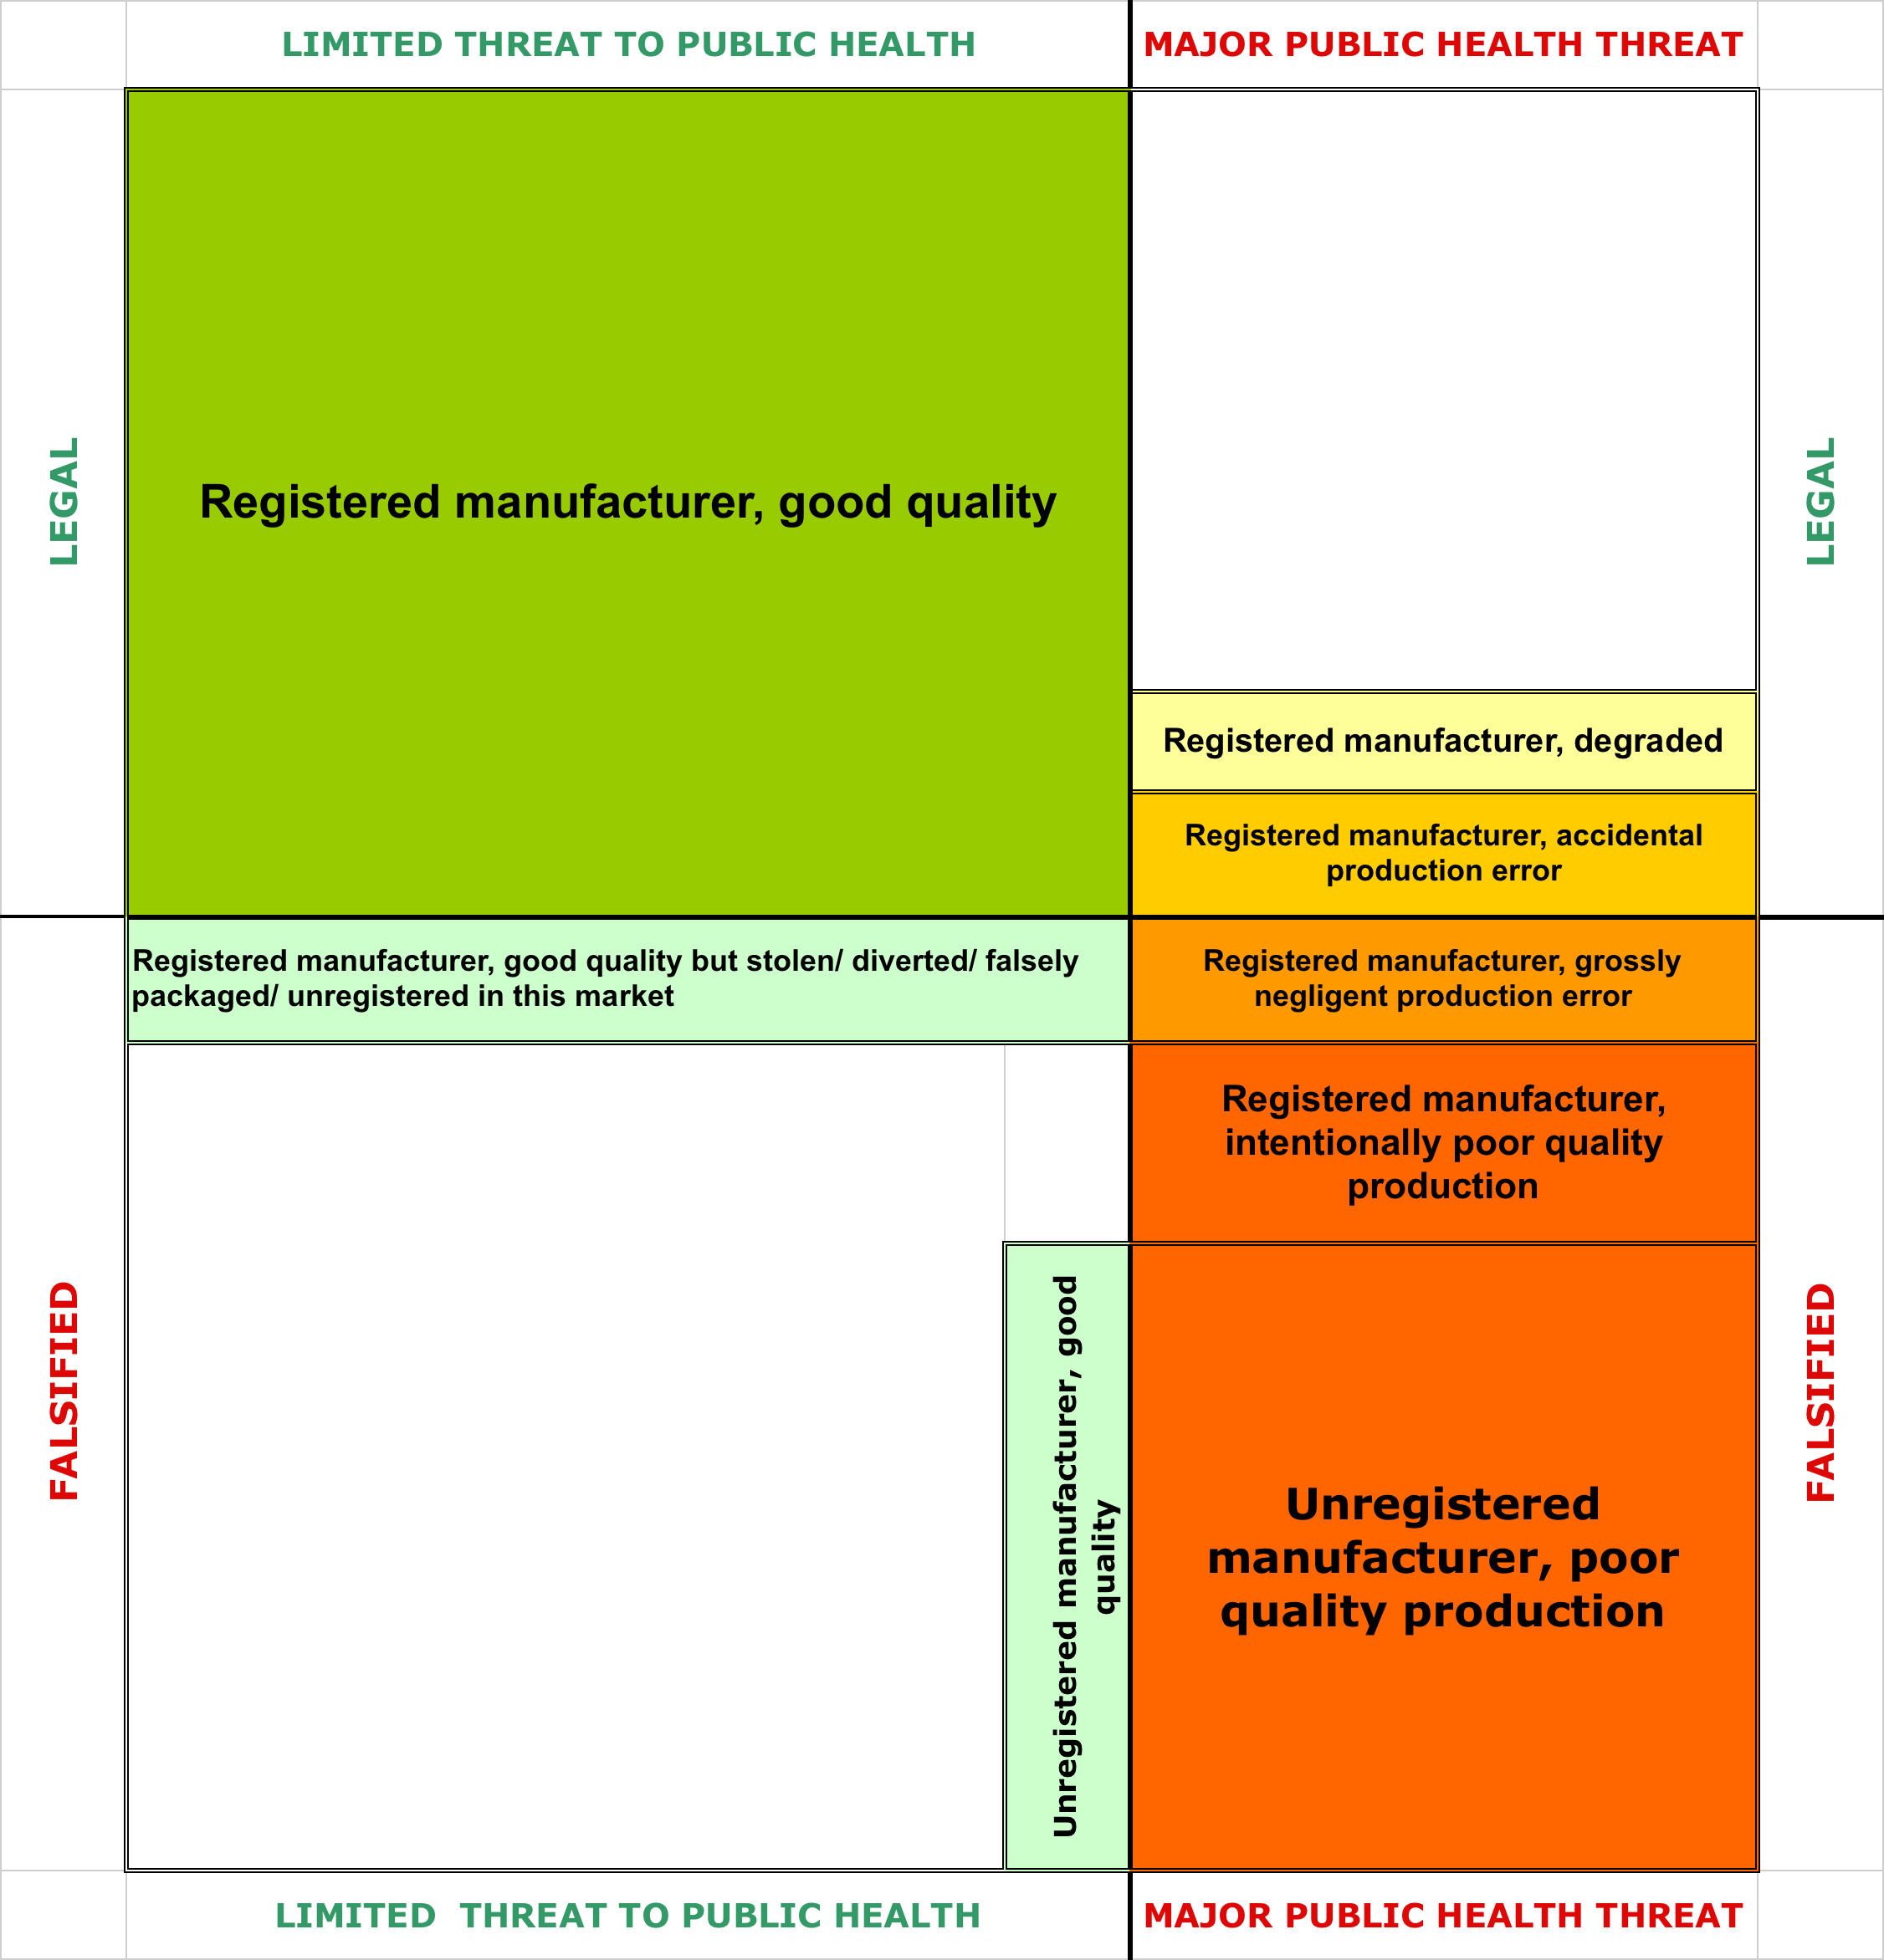
Figure 1 illustrates the different types of medicines in the market; it is not drawn to scale, but is intended to indicate that the size of each box is variable. The schema is divided vertically by the potential threat to public health, and horizontally by the regulatory and legal landscape. Products in the upper left hand quadrant are made by legitimate manufacturers, are of high quality and comply with all rules on registration and labelling. The lower left hand quadrant includes products that are of good quality in terms of composition, but which do not comply with all regulations. These may include medicines sold in markets where they are not licensed. Drugs that are good quality bio-equivalent copies of innovative products still under patent would also fall into this quadrant, whether or not they are made by a licensed manufacturer. From a public health point of view these products do not in themselves require urgent action, except to the extent that it is considered necessary to protect the investment of companies, including innovators, which have borne the costs of medicine development and regulatory compliance. Quality medicines stolen or otherwise diverted from their intended markets, for example from free public providers to private sellers, also fall in to this category because they do not themselves pose a direct threat to health. It's worth noting, however, that medicine theft can influence drug quality more broadly. When medicines intended for free distribution in public facilities are stolen for resale in private markets, sometimes in a different country, the public facility is left with a stock-out. Either the clinic steps outside of its regular supply chain to fill the gap, or the patient must get her medicines elsewhere. In either case, the chance of poor quality medicines entering the supply chain is greatly increased. What's more, the stolen medicines are unlikely to be transported and stored in accordance with best handling practice, and are thus at risk of degrading. While police action may be necessary to prevent or prosecute theft, most action in this quadrant is likely to include bureaucratic and civil enforcement of existing regulations.
Figure 1: Different categories of poor quality medicines
Of more concern from a public health point of view are the products that fall into the categories on the right hand side of the diagram. These include products that were of good quality when they left the factory door but which have degraded because of inappropriate conditions during transport or storage, or because of the passage of time. Accidental production or packaging errors in generally well-regulated factories can also lead to poor quality medicines entering the supply chain. Some authorities use the term "substandard" to refer to these types of medicines, distinguishing them from the negligently produced or falsified products described below. They include correctly manufactured medicines that have been mistakenly/ negligently packaged or labelled as a different product. A public health response is needed to reduce the prevalence of substandard medicines; this includes action to improve the supply chain and to ensure that systems are in place to detect and respond rapidly to production errors, including through product recalls. These systems should support manufacturers, incentivising them to report and correct manufacturing errors.
Where manufacturing errors are the result of gross negligence or consistently poor production standards within a factory, the products tip over into the lower right hand quadrant. Broadly, there are three types of manufacturers in this quadrant, all of them knowingly involved in the production of medicines which do not meet acceptable standards in terms of content, formulation, or correct labelling. The first group are unregistered manufacturers: they often make medicines that are entirely free of active ingredients, that contain incorrect amounts of the stated active ingredients, or that contain different active ingredients altogether, sometimes toxic. The second type of manufacturer in this quadrant are licensed producers who have systematically underinvested in good manufacturing practice and quality control. This underinvestment leads to the persistent production of poor quality medication; it is grossly negligent at very best, and should be regarded as criminal. Finally, some of the manufacturers producing products that fall in this quadrant have made the investments needed to meet the highest quality standards. However they choose to run "tiered production", producing lower quality medicines for markets with less regulatory oversight. (Bate et al. 2014; Institute of Medicine 2013; Caudron et al. 2008) Where this kind of production is intentional or persistent, it should again be treated as criminal. However, negligent underinvestment in quality control systems and deliberate production of poor quality medicines are fiendishly difficult to prove and therefore to prosecute, especially if they occur in factories that also sometimes produce batches of adequate quality. Public health agencies clearly need to maintain systems to detect these persistently or fraudulently poor quality medicines and remove them from the market, but they rarely have the wherewithal or the authority successfully to prosecute licensed manufacturers of these products.
The picture is further complicated by the extremely fragmented and increasingly globalised nature of the pharmaceutical market. All of the possibilities depicted in the diagram apply to active pharmaceutical ingredients (APIs) as well as to finished products. Contaminated active ingredients may unwittingly be made into poor quality end-products in factories that themselves employ good manufacturing processes. Notorious examples include a batch of the blood thinner Heparin made in the United States using contaminated API imported from China by the US firm Baxter pharmaceuticals, which led to at least 149 deaths. (Zawisza 2008).
Pathogens are clearly indifferent to the regulatory or legal status of the drugs that confront them within a patient. Their evolution is, however, affected by the ingredients and formulation of a medicine and its interaction with patient characteristics. The following section considers the ways in which poor quality medicines of different types affect the development of resistance.

The contribution of poor quality medicine to AMR
The relationship between antimicrobial agents and susceptible and resistant pathogens is complex, and varies depending on the life cycle of the pathogen, the specific action of the drug in question and the metabolism of the host, itself sometimes genetically determined. Broadly speaking, pathogens with short life-cycles and high rates of reproduction are likely to become drug-resistant: viruses, bacteria and protozoa.
When a pathogen multiplies, the "offspring" may contain mutations which reduce (though initially rarely eliminate) its susceptibility to a given medicine. The longer the infection lasts, and the greater the rate of reproduction, the more likely such a mutation will arise. However the mutation generally also carries a fitness cost which makes it less likely to reproduce than its susceptible siblings. Without treatment, the susceptible strains will thus continue to dominate, and resistant strains are unlikely to spread. A sufficient dose of a medicine early during an infection will kill susceptible strains, and will probably also suppress the still rare newly-mutated pathogen so that it does not multiply widely enough for onward transmission. This is especially the case if the medicine is rapidly eliminated from the body.
Sub-therapeutic doses of medicines, however, selectively kill the susceptible strain. This reduces reproductive competition, and allows the more resistant strain to multiply more rapidly than the susceptible strain. Medicines that stay in the blood-stream for longer amplify this effect compared with those that are rapidly eliminated, because the selective pressure is repeated over more reproductive cycles.
Once de novo resistance has emerged, it can be transmitted in various ways including, in the case of bacteria, through direct exchange of genetic material. The population dynamics for transmitted resistance are rather different: transmitted strains tend to have developed higher fitness and may be selected for at lower drug concentrations than de novo resistance.
Though variation across pathogens is great, the broad implication is that resistance is most likely to develop when high concentrations of pathogens meet concentrations of medicines that are low, but not too low to kill the competitive susceptible bacteria. Resistant strains can then spread under lower selective pressure.
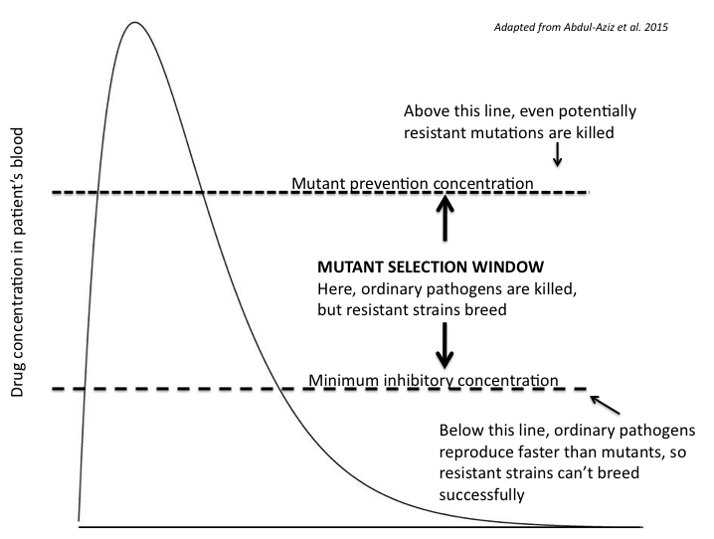
Figure 2: Drug concentration and the selection of drug-resistant pathogens
Poor quality medicines can help create these conditions in several ways:

Reduced delivery of API
Medicines manufactured with insufficient API, either deliberately or as the result of a production error, will clearly be sub-therapeutic. Exceptionally low levels of API may be less harmful in promoting resistance than intermediate levels.
Degraded medicines are previously high-quality drugs that have become damaged since production. Some active ingredients are more likely to degrade than others, but degradation in most cases leads to a loss of potency. In addition, degradation of excipients may affect the way the medicine dissolves, and thus the bio-availability of the medicine to the patient.
Poorly formulated medicines (especially pills or suppositories) may dissolve incorrectly in the gastro-intestinal tract, affecting the volume and pace at which active ingredients are released and thus their bioavailability in the blood. The amount of active ingredient delivered to the bloodstream may be reduced by poor formulation, including the use of substandard excipients. Even the correct amount of medicine, if it is released too quickly or too slowly, can promote the development or replication of resistant pathogens. (Leslie et al. 2009)
A lack of adapted paediatric formulations of common antimicrobials also affects the delivery of active ingredients. In many markets, formulations and dosages appropriate for young children are relatively rare. Parents cut up pills, crush them and dissolve them as best they can, delivering very varied levels of active ingredient. Even where paediatric formulations are available, dosage is often based on research conducted primarily in adults. One large-scale study of artemether–lumefantrine treatment for malaria which found that treatment failure (and thus the risk of resistance developing) was highest in children concluded that paediatric dosages were at fault. (WWARN AL Dose Impact StudyGroup 2015)

Increased concentrations of pathogens
"Medicines" with no correct API lead to treatment failure. This may lead to death or disability, with disastrous consequences for patients and their families, but more limited implications for resistance. But by failing to suppress infection, drug-free "medicines" may also prolong infection and lead to a build-up of pathogens: severe disease with high viraemia, parasitaemia or bacteraemia. This increases the chance of infections spreading, as well as of mutations developing. The same is true of medicines with very low concentrations of active ingredients. These last appear to have become more common after binary colorimetric tests were introduced by many medicine regulatory agencies to test for the presence or absence of the advertised active ingredient.
Sometimes, medicine falsifiers will use substitute active ingredients, most often an older, cheaper treatment for the same condition. Chloroquine, for example, is often used in place of newer antimalarials, delivering the customary bitter taste and perhaps reducing fever, but not effectively clearing parasites. These older treatments have often fallen out of favour precisely because they are ineffective against increasingly resistant strains of a pathogen. Re-exposing pathogens to these medicines allows for a build-up of the pathogens, as well as an increased selective pressure against medicines that might otherwise have regained effectiveness.(Ndiaye et al. 2012)

Unprotected partner medicines
As concern about drug resistance grows and greater efforts are made to forestall its spread, combination therapies are becoming more common. Administering several medicines that act in slightly different ways reduces the likelihood that resistant strains will arise because a mutation that protects against just one of the medicines will confer no protection against the others, leaving the mutant strain vulnerable to elimination by one of the partner medicines. If one or more of the drugs in the combination are of poor quality, however, the "unprotected" medicine will effectively revert to being monotherapy, and thus become vulnerable again to the development of resistance.

Physician behaviour
"Treatment" with medicines that deliver no or very low concentrations of active ingredients to people with infections also influences physician behaviour in ways that can promote further resistance. In many countries where infectious disease is common, diagnostic facilities are thin on the ground. Indeed doctors quite often use treatment as a form of diagnosis: they prescribe medicines for the infection they most suspect. Faced with patients who do not respond to treatment, physicians tend to suspect misdiagnosis before they suspect the quality of the medicines the patient has been taking. If treatment fails, they move on to prescribing a drug for the next most likely source of infection. If misdiagnosis can be ruled out, their suspicion turns next to resistant infection. Indeed in several cases, treatment failures were initially ascribed to resistance when they were actually caused by medicines that had incorrect active ingredients or poor bioavailability. (Basco et al. 1997; Leslie et al. 2009; Chandra Sahoo et al. 2010)
The "correct" provider response would be first to use diagnostic testing, then, if treatment fails, to request susceptibility tests for the current drugs: if a pathogen is susceptible to a medicine to which a patient is not responding, it ought to put physicians on high alert for poor medicine quality. But susceptibility testing, where it is available at all, is time-consuming, technically demanding and expensive. By far the more common response, especially in developing countries, is to switch patients onto "stronger" medicines such as broad-spectrum antibiotics -- switches that often take place before susceptibility test results have been obtained. This undermines efforts to promote stewardship and to limit the pressure on newer and more expensive classes of medicines.
There is a circularity to this problem. Though susceptibility testing is not as widespread as it should be, it is far more common than testing for drug quality. If a patient does prove to have a resistant strain, the quality of the medicine they are taking will not be called into question. In practice, of course, high levels of resistance and poor quality medicines often co-exist, so actual resistance can mask problems with medicine quality just as effectively as suspected resistance does.
One solution to both of these problems would be to put simple tools to check medicine quality into the hands of health care providers. Diagnostic tools are discussed later in the paper.
Because falsified and other types of poor quality medicines tend to cluster in markets where regulation is weak, there is also a likelihood that patients who have been taking "medicine free" medicines (and have thus built up high concentrations of pathogens) switch to other drugs that are also poor quality. Where these new medicines deliver more substantial but still sub-therapeutic amounts of API, this will increase the likelihood that resistant strains will thrive.
Other measures of poor quality, including an excessive dose of the active ingredient or an active ingredient entirely different from that stated on the packaging, can have very serious consequences for patient health, but their contribution to resistance is more limited.
Table 1 sets out broadly the potential contribution that different types of poor quality medicines make to anti-microbial resistance.
Table 1: Medicine quality problems and their contribution to antimicrobial resistance
No contribution to AMR | Limited contribution to AMR | Extensive contribution to AMR
100% API AND… | 0% API OR… | Sub-therapeutic API OR…
Correct bioavailability AND… | >100% API OR… | Poor formulation limits bioavailability OR…
Not degraded | Wrong API | Degraded
As the following sections make clear, neither the absolute effect of these different defects nor their distribution across the manufacturing and regulatory spectra illustrated in Figure 1 are clear. However it is possible to predict broadly how the different causes of resistance map on to the different categories of poor quality medicine.
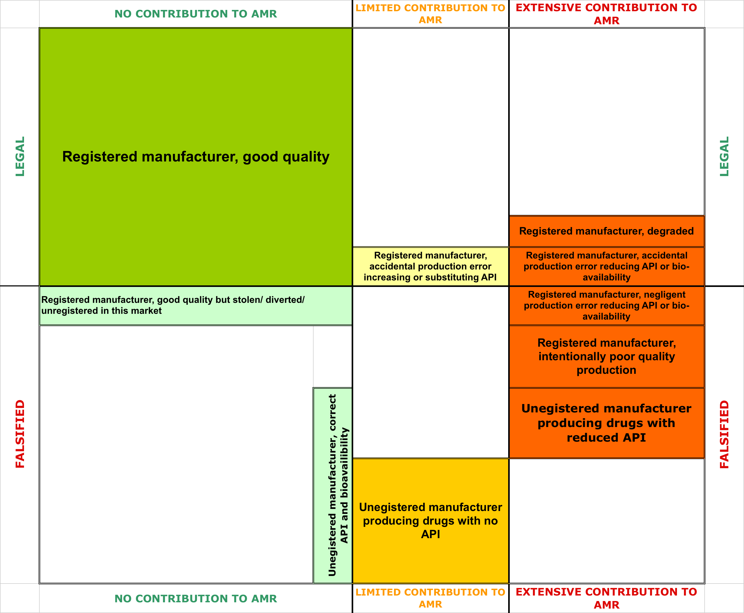
Figure 3: Contribution of medicine quality to anti-microbial resistance
As Figure 3 shows, some of the legally more benign causes of poor quality medications are, from the point of view of fostering antimicrobial resistance and therefore for broader public health, actually more dangerous than out-and-out criminal production of pills or other products with zero active ingredients. For those interested in reducing the risk of resistance arising from poor quality medication, the first orders of business are to improve the transport and storage of legitimate medicines, and to promote verifiable good manufacturing practice among registered producers. Tackling the criminal production of products with deliberately sub-therapeutic levels of active ingredient is another critical priority.

Quantifying problem of poor quality medicine and its contribution to resistance
Figure 3: Contribution of medicine quality to antimicrobial resistance
The laboratory analyses described below confirm that falsified and substandard medicines -- including those with sub-therapeutic levels of API and/or formulations that inhibit dissolution and restrict bioavailability -- are common in countries with weak regulatory systems. Many of those countries also have high prevalence of infectious diseases. Scientific theory and common sense thus both suggest an inevitable link with antimicrobial resistance. It is not, however, possible to prove or quantify this link using "gold standard" methods such as randomised placebo controlled trials, since researchers can clearly not ethically randomise patients to take medicines that are known to be of poor quality.
Because poor quality medicines so often deliver subtherapeutic doses of an active ingredient, the link between poor quality medicines and the development and spread of resistance can, however, be deduced from other types of data: mathematical modelling, in vitro and animal model studies, early clinical trials comparing different dosages of new antimicrobials, and the analysis of patient outcomes across large sets of aggregated clinical data that record different drug dosages. The triangulation of these various data sources provides us with significant understanding of how medicine quality and antimicrobial resistance are linked.
Mathematical models for both antibiotics and antimalarials predict that resistance is most likely to develop in a subtherapeutic window, increasingly known as the "mutant selection window", in which drug concentrations are too low to kill resistance mutations outright, but are high enough to kill susceptible pathogens and create a reproductive advantage for the mutants. (Lipsitch & Levin 1997; White et al. 2009; Stepniewska & White 2008; Abdul-Aziz et al. 2015). Lipsitch and Levin's models further suggest that the effect is greater when a patient is exposed to consistently sub-therapeutic levels, compared with being exposed to intermittent levels of correct and lower dosages. Importantly, this implies that a patient who takes substandard medicines correctly is more likely to become a host for new resistant strains than one who is exposed to sub-therapeutic drug levels because they do not take a full course of quality medication.
A modelled investigation of the effect of β-lactam treatment on the emergence of resistant strains of Streptococcus pneumoniae found that high doses at low frequencies produced more highly resistant strains, but at far lower prevalence than low doses of antibiotics given with greater frequency. In other words, the conditions which most closely resemble countries in which substandard medicines are widely available on the open market -- repeated exposure to sub-therapeutic doses -- developed the highest prevalence of resistant strains.(Opatowski et al. 2010)
As with all modelling, the utility of models of antimicrobial resistance is highly dependent on the robustness of the model assumptions and the quality of input data. The models described above, developed by some of the most respected scientists in their fields, use input data from both in vivo and in vitro studies. Though they will grow more reliable as the input data improve, they are considered to provide a useful indication of the relationship between current dosing strategies and the development and spread of resistance. A recent and thorough review of modelled, in vitro and in vivo evidence of the relationship between dosing and resistance for different classes of antibiotics concludes that "contemporary antibiotic dosing tends to produce medicine concentrations within the critical zone where they selectively amplify the growth of resistant mutants".(Abdul-Aziz et al. 2015) In other words, current clinical guidelines for dosing, developed with an exclusive focus on patient outcomes, are already too low to prevent the development of antibiotic resistance. Values close to the bottom of the mutant selection window (i.e. where the drug concentration is barely above the minimum level needed to suppress visible grown of the pathogen) are most likely to result in the development and spread of resistance.
Very few clinical studies directly measure the relationship between drug dosing and resistance. Khachman and colleagues combined data from 102 patients in intensive care treated with ciprofloxacin with modelling of the mutant selection window for Pseudomonas aeruginosa and Acinetobacter baumannii. They found that in more than half of cases, current dosing regimes failed to minimise the selective pressure for resistance.(Khachman et al. 2011) The implication for substandard medicines is mixed: where even therapeutically "correct" dosages are at risk of promoting resistance, small additional short-falls in the percentage of active ingredient available to patients due to poor medicine formulation (whether deliberate or accidental) will probably push drug concentrations closer to the minimum inhibitory concentrations, thus amplify the likelihood of resistance. Very poorly formulated medicines and those with extremely low levels of API will probably produce drug concentrations below the threshold at which they suppress even the susceptible strains of pathogen. This may be catastrophic for the individual patient, but it will be unlikely to promote antimicrobial resistance.
Very rarely, a case report may provide direct evidence of the relationship between substandard medication and treatment failure. Keoluangkhot and colleagues, for example, report on treatment failure in a patient with uncomplicated P. falciparum whose remaining vials of artemether were shown to contain just 74% of the recommended API. A similar case of treatment failure in a US Peace Corps volunteer with P vivax found that other samples from the same batch of antimalarial he had been taking in Namibia contained less than half the labelled dose of primaquine phosphate. (Keoluangkhot et al. 2008; Kron 1996). More recently, a traveller returning to Spain from Equatorial Guinea with malaria that remained unresolved despite treatment with locally-acquired artesunate monotherapy was able to provide left over pills for laboratory analysis. They were found to contain no active ingredients.(Chaccour et al. 2012)
Clinical data also point indirectly to a link between under-dosing (and thus substandard medication) and increasing antimicrobial resistance. The Worldwide Antimalarial Resistance Network (WWARN) has pooled and analysed individual data from thousands of malaria patients worldwide, comparing doses of various antimalarial regimes with parasite clearance times. For both artemether–lumefantrine and artesunate-amodiaquine, the group found that lower doses were associated with significantly longer parasite clearance times, and greater recrudescence.(WWARN AS-AQ Study Group 2015; WWARN AL Dose Impact StudyGroup 2015; WWARN DP Study Group 2013) The studies were not able to measure resistance because molecular data were not available. There is, however, a strong correlation between high parasitaemia, slow parasite clearance, recrudescent infection and the emergence of resistance in Falciparum malaria. (White et al. 2009) It thus follows that if under-dosing is associated with longer parasite clearance times and more recrudescence, it is also highly likely to be contributing to resistance.
In summary, while the link between poor quality medication and the development of resistance cannot ethically be established or measured through human trials, all evidence points to a strong relationship between antimicrobials that deliver low or intermediate doses of active ingredients and the development and spread of resistant strains of pathogens.

What proportion of antimicrobial medicines are poor quality?
The magnitude of the contribution of poor quality medication to resistance depends in large part on how many antimicrobials there are in the different boxes shown in Figure 3, and in particular the size of those boxes shaded red or orange.
There is a chronic shortage of reliable data about medicine quality, especially in the countries most likely to be affected. In countries with strong regulatory regimes, such as those of the European Union and North America, reports of falsified medicines are rare. Most involve high value products and "lifestyle" drugs frequently traded over the internet, such as erectile dysfunction medications and steroids. Canada's regulatory agency reported only four cases of falsified medicines in the supply chain over the nine year period to 2013, all of them involving erectile dysfunction drugs. Close to 650 products were deemed to be substandard over that period, 10 percent of them antimicrobials. (Almuzaini et al. 2014). The UK, for its part, reported just 11 cases of falsified medicines in the 11 years to 2011, together with 269 cases of substandard medicines. Some 13 percent of the substandard medicines were antimicrobials. (Almuzaini, Sammons, et al. 2013) The definition of substandard in these cases was not necessarily restricted to ingredients or formulation; it included errors in packaging such as defective tamper-free devices.
Evidence from other regions suggests that in lower income countries, the prevalence of poor quality medicines is far higher, and both falsified and sub-standard versions of low-value antimicrobials are common. A handful of frequently-cited reports have suggest that upwards of half of medications in some sub-Saharan African countries are falsified or substandard, but most of these are based on unrepresentative samples. Very few studies distinguish clearly between the different categories of poor quality medicines. Many existing studies inspect packaging for signs of falsification and test for active ingredients; far fewer test for dissolution (an indicator of bioavailability), and of those collecting samples in the field, virtually none are able to distinguish samples that have become degraded over time from those that were substandard when they left the factory.
Table 2 summarises the major sources of data about the prevalence of poor quality medicines; this section describes the biases inherent in each.

Table 2: Summary of sources for data on poor-quality medicines
Source | Description | Strengths | Weaknesses
Randomised surveys | Systematic random sampling and testing. | Best indicator of magnitude of problem overall. | Expensive, time-consuming, unsuited to urgent public health response.
Risk surveys | Purposive sampling of suspicious medicines. | Identifies areas in need of public health action. | Can overstate magnitude of problem.
WHO Rapid Alerts | Reports of newly-discovered falsified or substandard medicines submitted by national focal points. | Data available in real time. Standardised reporting format. Public health action possible. Good for advocacy. | Only actionable cases made public. Toxic or API-free medicines overrepresented compared with substandards.
PSI reports | Database supported by pharma industry. | Includes confidential industry reports and public reports. | Only aggregate data made public, annually. Definitions of limited public health relevance.
USP medicine quality database | Database maintained by USP, mostly antimicrobials in Asia, Africa, Latin America. | Open access. Custom reports with detailed data available. Includes reports of samples that pass QC. | Most results based on screening tests of limited sensitivity.
Seizure data | Periodic reports by customs authorities and INTERPOL. | Good for advocacy. | Includes trademark and licensing violations. Definitions of limited public health relevance.

Random surveys of medicines at point of sale
Theoretically, the least biased estimates of medicine quality should come from surveys of medicines acquired from a random sample of all the outlets from which patients might acquire medicines. Though some published guidance is available,(Newton et al. 2009; United States Pharmacopeia 2007; World Health Organisaton 2014) random surveys remain rare. They are logistically complex and rather expensive, and because they are time-consuming, the data they provide cannot be acted upon rapidly. Most random surveys in fact include only a sub-section of outlets in their sample frame, such as registered pharmacies or informal markets. They rarely provide a full picture of the quality of medicines that may be acquired by patients in any given country.
By far the greatest concentration of medicine quality studies concerns antimalarials, and in particular artemisinin and its derivatives. In this relatively well-investigated field, only 21 published studies have used random sampling techniques; all have been conducted since 1998. (Worldwide Antimalarial Resistance Network 2015)
Even this limited pool does not use comparable sampling techniques or testing methods; that, and the great variation in market and regulatory environments between countries, ensure wide divergence in results. Of note, however, are changes found in the few places where attempts have been made to use comparable methods over time. In the highly scrutinised field of artemisinin derivatives, the earliest southeast Asian surveys conducted using random sampling found very high levels of both falsified and/or substandard medicines. In Laos, for example, 27/30 artesunate samples collected in 2003 by mystery shoppers using random sampling were found to be falsified, containing no detectable artesunate at all. Though the sample size is small, the proportion is astoundingly high. Repeating the survey nine years later with a larger sample size (142 medicines labelled as antimalarial) and including more types of antimalarials, Tabereno and colleagues found that all samples contained the expected active ingredient and packaging analysis did not suggest any deliberate falsification. However close to a quarter had less than 90% of the required drug concentrations.(Sengaloundeth et al. 2009; Tabernero et al. 2015)
Similarly in Cambodia, re-analysis of data from a survey of antimalarials collected from a random sample of public and private outlets in 2009 indicates that 25% of the medicines collected were either falsified or substandard. Unusually, this survey included dissolution testing. While many samples failed because there was no or very limited active ingredient present, failure to release active ingredients at correct concentrations in conditions mimicking those of the stomach were nearly twice as common. Though the survey did not make a distinction between substandard and deliberately falsified products, 8/43 failed samples contained no active ingredient at all, a clear indication of falsification.(Phanouvong 2009)
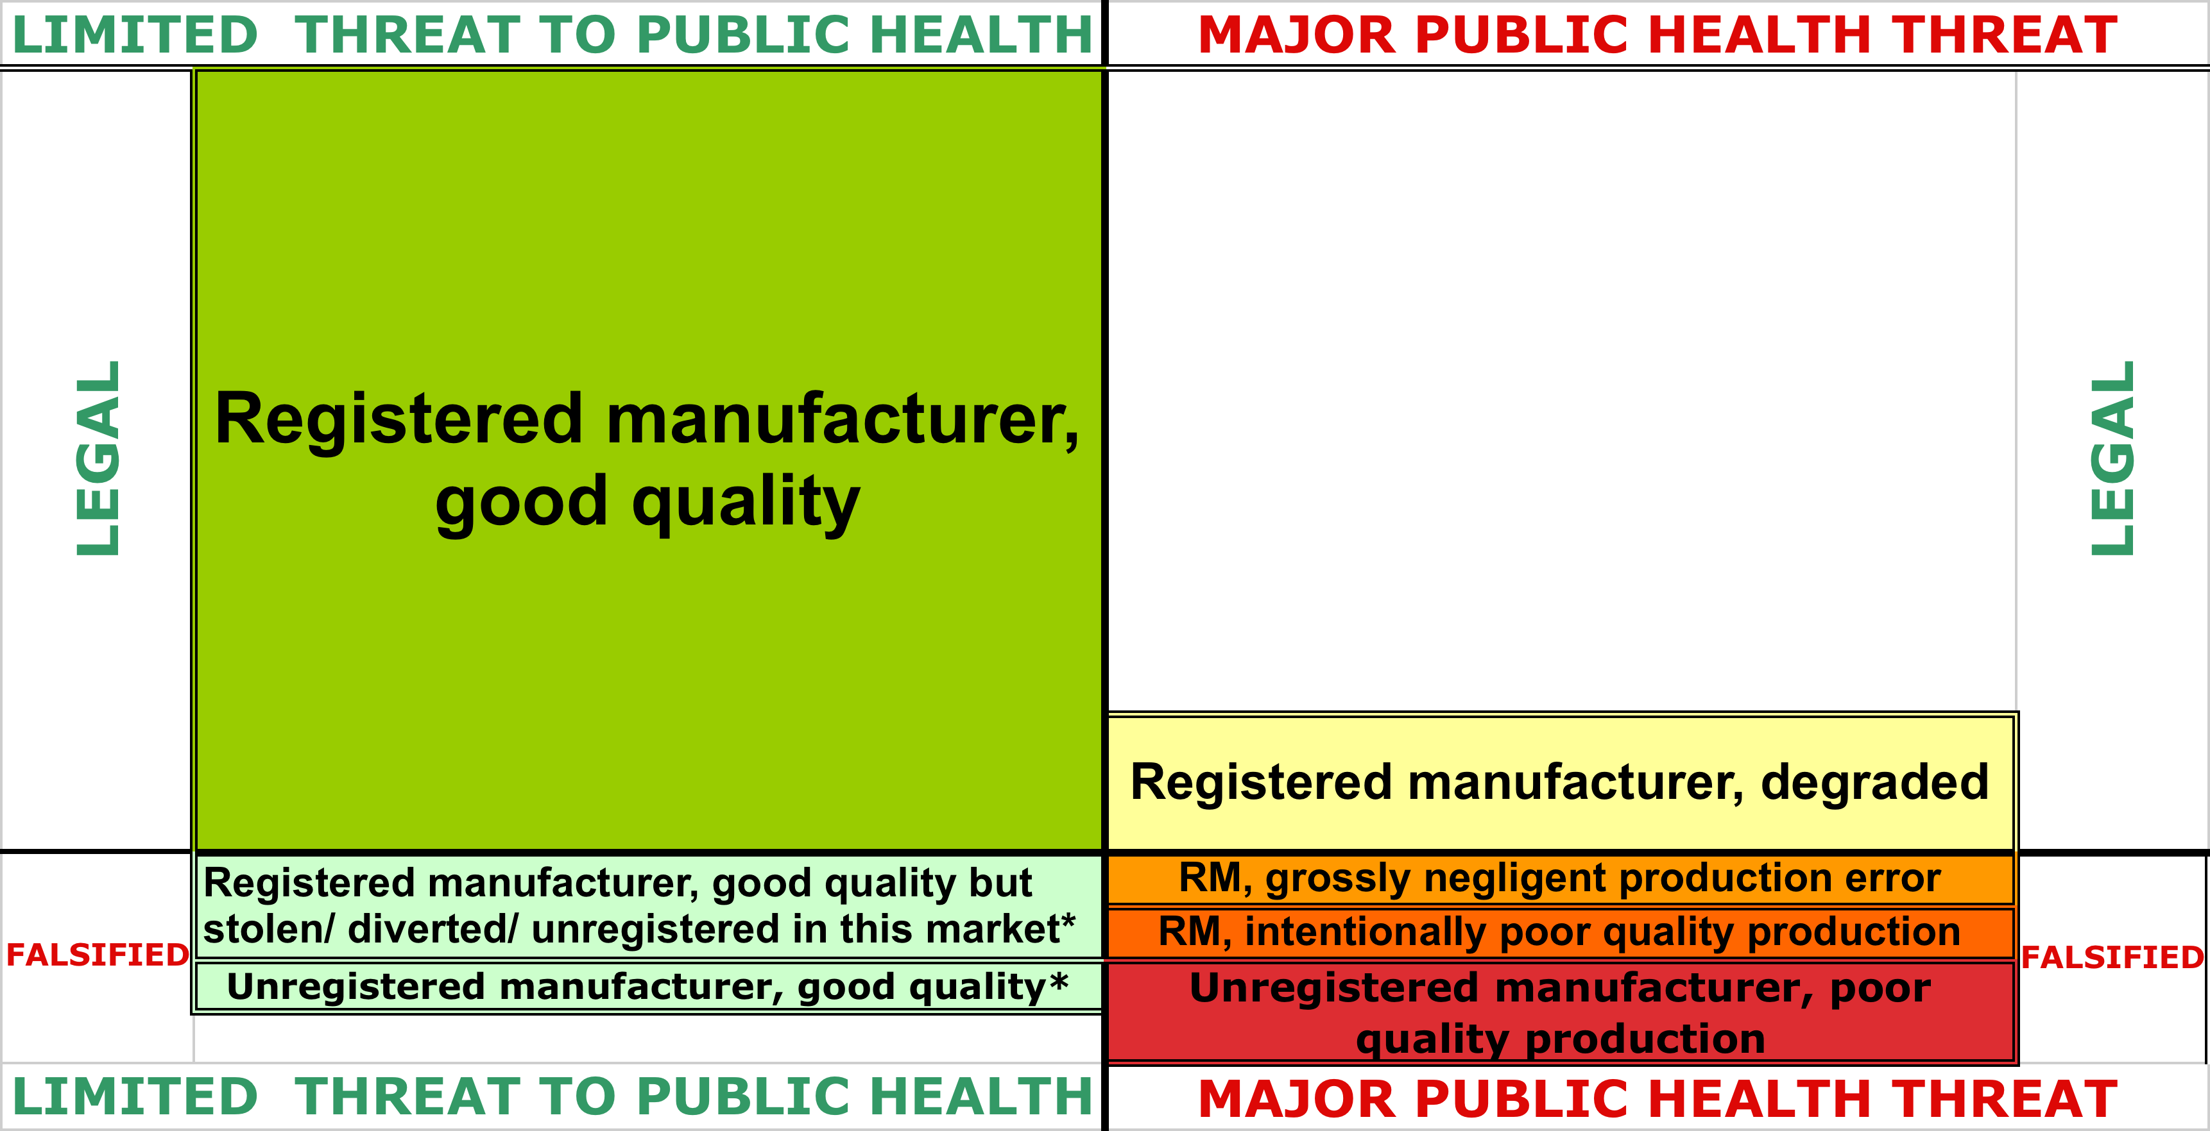
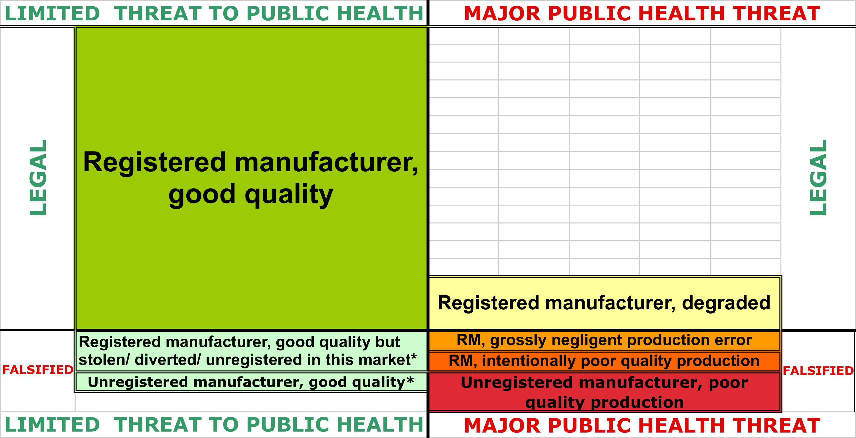
* These are sheer guesses; no data were available to estimate the size of these boxes. To reflect the overall proportion of medicines that met pharmacopeial standards, however, the top left-hand quadrant has been reduced proportionately.
Figure 4: Estimated extent of antimalarial quality issues, Cambodia 2009
Figure 4 is an attempt to redraw Figure 1 to scale, based on a re-analysis of the data collected in Cambodia in 2009 and published by US Pharmacopeia. The exercise is an uncertain one, because it is so difficult to know which of the boxes on the right hand side a given medicine should fall in. But it gives an overall snapshot of the distribution of quality problems for one medicine in one market at one point in time. Clearly, even in the troubling setting of northwestern Cambodia, at the very time and in the very place that artemisinin resistance was developing, the vast majority of antimalarial medication -- around three quarters, was of acceptable quality. This underlines the fact that those concerned about antimicrobial resistance should draw no comfort from the fact that poor quality medicines make up only a small fraction of the market.
These study results led to concerted action on the part of the Cambodian government and its partners.(Krech et al. 2014) In another random survey in Cambodia less than two years later which sampled only from the private sector, no antimalarials suspected of being falsified were found at all. Poor-quality medicines, mostly containing 85% of the expected artemisinin derivative, were, however, worryingly common. Some 31% of the antimalarials tested fell in to this category and the partner medicines designed to delay the development of resistance to artemisinin monotherapy were even worse: up to 78% of medicines tested were considered substandard if all drugs in a combination were included. Dissolution testing was not performed, so it's not possible to compare likely bioavailability rates with those of the earlier survey.
Overall, recent studies of random samples show a similar pattern, finding unexpectedly low levels of obviously falsified medicines, together with sometimes worryingly high levels of substandard medicines.
Table 3: Substandard and falsified artemisinin combination therapies collected through random sampling and tested by HPLC, various countries
Country | Year samples collected | Brands | Percent substandard | Percent falsified
Rwanda | 2008 | 1 | 6.2 | 0
Cambodia | 2010 | 21 | 31.3 | 0
Ghana-Kintampo | 2011 | 31 | 37.0 | 0
Tanzania | 2010 | 37 | 12.0 | 0
Tanzania | 2011 | 46 | 2.2 | 0
Nigeria - Enugu Metro | 2013 | 131 | 6.6 | 1.2
Equatorial Guinea -Bioko | 2014 | 142 | 1.6 | 7.4
Nigeria - Ilorin | 2013 | 77 | 7.7 | 0.8
Source: (Kaur 2015)
Table 3 summarises the results of other surveys of antimalarials collected using randomised sampling designs. It is important to note, however, that none of these studies covered all types of medicine outlets. A review of studies which compared licensed with unlicensed outlets show that there are significant differences in quality in the medicines supplied by different sectors.(Almuzaini, Choonara, et al. 2013)
The variation even within the small handful of random surveys of medicine quality in a single therapeutic class underlines the difficulty of arriving at a credible estimate of the prevalence of medicines which might contribute to antimicrobial resistance because of their poor quality. Though these surveys represent the closest to the "gold standard" method for achieving that particular aim, they use:
- different sample frames, including a focus on different sub-sections of the distribution chain and market
- various definitions for "substandard", including different pharmacopeial limits for the same active ingredients
- different tests, investigating various different indicators and dimensions of "quality", including packaging, composition, disintegration/dissolution and indicators of degradation
Though there are fewer random surveys of medicines in other therapeutic categories, those that do exist show equally great variation. One frequently quoted study published in 2001 found that 48% of 581 samples across several therapeutic categories acquired from a random sample of registered pharmacies in two Nigerian cities contained active ingredients outside pharmacopeial limits, though generally not very far outside -- fewer than one percent were blatantly drug-free fakes.(Taylor et al. 2001)
The analysis of samples randomly collected in the field is expensive and time-consuming and thus arguably inappropriate for the regular monitoring a sector that responds rapidly to changing opportunities. And the world of criminal falsification is nothing if not responsive: falsifiers are, after all, driven like many other businesspeople by the desire to maximise profit. They are distinguished from many other businesspeople in that they must also factor into their cost-benefit analyses the likelihood of getting caught. The apparently dramatic fall in falsified antimalarials in the increasingly vigilated markets of Southeast Asia and the concurrent rise in harder-to-detect and harder-still-to-prosecute substandard medications may point towards market adaptation on the part of criminal networks.(Hajjou et al. 2015; Phanouvong 2015; INTERPOL 2014) In low and middle income countries, a relatively high proportion of medicines for malaria and HIV (and to a lesser extent TB) trade within the confines of large, multi-lateral programmes. It's therefore likely that criminals will shift further into less regulated and higher volume products such as antibiotics. From the point of view of those wishing to prevent antimicrobial resistance, these market adaptations are potentially significant. Fewer brazen fakes and more medicines with not-quite-enough active ingredients and poor bioavailability will increase rather than decrease the spread of resistant pathogens.

Published studies based on "convenience" samples
The majority of published studies of medicine quality are based on samples of drugs collected unsystematically. The results of these studies are thus even more difficult to interpret or compare across time or location.
Two summary tables, each from recent reviews of studies that attempt to measure the quality of medicines in different countries, are reproduced in the Appendix. While both tables give some indication of the results, the differing information they include about medicines tested, testing methods and outcome in itself reflects a lack of consensus about the core components of medicine quality studies. Unhelpfully, neither table includes information about sampling methods or source of samples, although this is critical information in attempting to interpret results. Alghannam and colleagues report simply that "most reported studies used convenience sampling and/or with limited sample size", while Kelesidis and Falagas, in a paper published in 2015, points to just two random surveys of antibiotics and fewer than half a dozen for antimalarials.(Alghannam et al. 2014; Kelesidis & Falagas 2015)
Some studies described as using "convenience" sampling include laboratory analysis of samples collected precisely because they were suspected of being falsified. Not surprisingly, these studies often identify very high proportions of poor quality medicines. Though they are rarely recognised as such, these are effectively risk-based samples. Collected more systematically, they could become the backbone of a sentinel surveillance system which, in conjunction with occasional random sampling for calibration, could provide a much better understanding of the burden of poor quality medicines worldwide.
The Worldwide Antimalarial Resistance Network collates all of the studies of the quality of antimalarial medicine into an open access database which can be searched by country, year, medicine, study type and other parameters. Data can also be visualised on a map. The database includes the headline results of the studies and links to PubMed entries, though the full papers are sometimes not accessible because of copyright restrictions imposed by academic publishers.

Reporting systems based on pharmacovigilance
All high and most middle-income countries maintain pharmacovigilance systems that involve the reporting to central authorities of medicines that cause adverse reactions or that are otherwise suspect. The World Health Organisation has over the last year or two been working very actively with medicine regulators in low and middle income countries to strengthen their pharmacovigilance. The WHO has strengthened its own Rapid Alert system to allow for the real-time sharing of important medicine safety information between countries.
Reporting systems based on pharmacovigilance will tend to overstate the proportion of toxic medicines, because it is often adverse reactions that brings the medicine to the attention of the authorities. The kind of dramatic treatment failure that results from medicines with no active ingredients at all may also lead to the reporting of this type of falsified drug. Medicines that provide sub-therapeutic doses of the correct active ingredient often provide some of the expected effects -- reduction of fever for example -- while prolonging the period of illness. While it is these drugs that are most likely to promote antimicrobial resistance, they are also least likely to be spotted and reported through pharmacovigilance systems.
Over the last four years, 78 countries have reported a total of over 800 discoveries of falsified or substandard products through WHO's Rapid Alerts system. The number has increased substantially each year in large part as a result of the training of focal points in high risk countries, especially in Africa. This focus explains in part the high proportion of all reports (48%) originating from Africa.
While only those that require immediate and serious public health action beyond the reporting country will lead to a public alert, data for all cases are entered into a database, providing a body of evidence which may help predict future trouble spots. Though medicines of all therapeutic categories are reported to WHO, the two most common categories are anti-malarials and antibiotics. Between them (and including reports of counterfeit insecticides and repellents aimed at malaria control) they account for 47% of all reported suspect medical products. Of the suspect anti-infectives reported, one in five was the common, low-cost antibiotic amoxicillin. (Pernette Esteve Bourdillon, personal communication 04 September 2015)
Though the database does not always distinguish between falsified medicines and those that are substandard because of sloppy production practices, the sheer volume of relatively high-volume low-cost anti-infectives reported corroborates evidence from field surveys that criminals are not concentrating exclusively on high value "lifestyle" drugs such as erectile dysfunction drugs or diet-related products.
The United States Pharmacopeia also maintains a database of the results of screening and sometimes confirmatory quality testing of medicines of public health interest in low and middle income countries in Latin America, Asia and Africa.(U.S. Pharmacopeial Convention Undated) The data are publicly available, and users can easily obtain customised tables looking at reports of testing outcomes by country, year, therapeutic category, source of sample and much else. This promises to be an important source of information over time. Its major limitations are that it is not clear what wider universe the analysed samples represent, and that most of the testing results come from Minilab tests, which are of limited sensitivity (see below).

Reports based on market intelligence and seizures
A similar database is maintained by the Pharmaceutical Security Institute (PSI), a non-government body funded by the pharmaceutical industry. The database includes information provided by pharmaceutical firms, which often maintain very well resourced teams that police the supply chain looking for violations of intellectual property. Data from public sources such as newspaper reports are also included. The data are not made public except on an aggregated level and are likely to be strongly biased towards high-value branded products made by the 28 innovator firms that fund the PSI. In mid 2015 PSI was reported to be considering admitting one of the larger manufacturers of generic medicines for the first time. Though public health organisations, including the WHO, have approached PSI to suggest routine collaboration and sharing of data, the industry body has so far refused. It does, however, provide specific information on an ad hoc basis and has made some heavily redacted data available to researchers.(Mackey et al. 2015)
In 2014, PSI reported 2,177 incidents of pharmaceutical crime, some of which involved large numbers of different medicines. These reports include violations of intellectual property and licensing, which do not necessarily threaten public health or promote the spread of resistant microbes. However even in this database, biased as it is likely to be towards high-value patented drugs, anti-infectives were the second most commonly-reported products.(Pharmaceutical Security Institute Undated)
Since 2008, the international police organisation INTERPOL has supported an increasing number of countries in carrying our coordinated campaigns against pharmaceutical crime, targeting sales over the internet as well as in pharmacies and traditional markets. The seizures made during these raids supplement seizures made by customs authorities and police in their routine work. The operations do not prioritise medicines of public health importance; data on the seizures will include products impounded because they violate trademarks or local registration requirements. Because INTERPOL and its partners share intelligence with the security departments of large pharmaceutical firms, seizures may also be skewed towards falsified versions of more lucrative branded drugs.(INTERPOL n.d.)

Need for a systematic surveillance system
For very many reasons, including the monitoring of likely contributors to antimicrobial resistance, it is imperative that the global health institutions support the development of a coherent surveillance system for medicine quality.(Riviere et al. 2012)
This is likely to mirror surveillance systems for complex infectious diseases such as HIV. Like AIDS case reports in the early days of the HIV epidemic, reports from pharmacovigilance and (more rarely) law enforcement systems act as alerts to the presence of a problem and signal the need for more proactive real-time surveillance. Sentinel surveillance using risk-based sampling provides a systematic and cost-effective way of monitoring trends over time while occasional random sampling across a wide spectrum of outlets allows for the calibration of sentinel data.
These systems are needed most desperately in precisely the places where current health information systems are weakest. Well-designed systems do not have to be costly, but they do have to be well integrated. Currently, pharmacovigilance systems are often institutionally divorced from routine disease surveillance systems: often, the medicine regulatory agency is responsible for medicine quality and safety reporting, while a division of the ministry of health is responsible for tracking infections and antimicrobial resistance. The two bodies are often in competition for funding and authority, and in some countries are barely on speaking terms. Law enforcement data are very rarely taken into account by public health authorities.
The experience of developing HIV surveillance systems, which are now stronger in many low and middle income countries than they are in parts of the industrialised world, and which include data from law enforcement in their risk population size estimates, shows that with sufficient guidance and support from global institutions, it is possible to craft affordable and effective surveillance for important public health issues. Similar investments in medicine quality surveillance would contribute to plausible estimates of the contribution of criminality and poor production practices to antimicrobial resistance worldwide.

Cost to legitimate pharmaceutical enterprises
As we've seen, we currently lack the data needed to make reliable estimates of the proportion of antimicrobials that are substandard or falsified. It's therefore clearly not possible to estimate the cost to industry of falsified and substandard antimicrobial medicines. Guesstimates of the losses caused to the pharmaceutical industry as a whole because of falsification of all classes of medicines are unsatisfactory: a widely-cited estimate from WHO dating from 2006 put the figure at US$75 billion, though the organisation has since said data are inadequate for accurate estimation. UNODC estimates that the trade in illegal pharmaceuticals between China, Southeast Asia and Africa is worth US$ 5 billion a year, but that is based on the assumption that around half of all medicines in the marketplace are falsified, which seem implausibly high.(UNODC 2013) INTERPOL values the medicines it seized in a week-long internet-related operation in 115 countries in June 2015 at US$81 million, but had those medicines been sold, much of the value added would have been realised in the same supply chain that would have benefited from the sale of legitimate medicines.
Though the magnitude of losses are hard to estimate, poor quality medicines will certainly affect the bottom line for producers of good drugs. Medicines made to high production standards cost more to produce than those that are made sloppily, because simply maintaining good manufacturing practice standards (GMP) and paying for certification add substantially to the cost of production. Active ingredients typically account for 40-50% of the total cost of manufacturing common antimicrobials to high standards (and thus for a higher proportion of costs in factories without GMP).(Bumpas & Betsch 2009) Skimping on production standards and active ingredients in medicine formulation are thus both effective ways of bringing down production costs for criminal manufacturers. Corners may also be cut on excipients, the material in which the active ingredient is bound or suspended; incorrect or poor quality excipients can affect dissolution and bioavailability. In short, poor quality medicines are a lot cheaper to produce than good quality medicines. They sell more cheaply too, though not always significantly. One study tested eight medicines on the WHO's essential drugs list bought in 17 low and middle income countries. On average, medicines found in the lab to be of poor quality sold for between 14 and 19% less than equivalent medicines that met quality standards, but the correlation between price and quality was far from perfect.(Bate et al. 2011) Where consumers do not value quality, or are unable to determine it at point of purchase, producers of quality medicines will find it hard to compete.
Since the cost of overt and covert mechanisms producers use to protect their brands and guarantee quality to consumers are largely independent of the cost of the product, it follows that legitimate producers are more likely to make these investments in high value products. There's less incentive to continue to invest in producing high volume, low value products such as common antibiotics at high quality (let alone to invest in innovation in these areas).
It is important also to consider the positive contribution of substandard medicines to the bottom line of the companies that make them. By cutting costs on GMP, by-passing registration costs, and even squeezing down costs of APIs, registered producers can save money and increase their own profit margins. They are likely to resist quality control measures that would force up the cost of production. In countries such as India, where very large numbers of companies make generic products to order for markets with poor regulatory capacity, the pharmaceutical industry has a great deal of political influence. By many accounts, that influence has been used to stonewall efforts by the WHO and others to increase scrutiny of manufacturing practices in order to increase quality standards. The Indian government, for its part, accuses WHO of using quality standards as a form of covert protectionism for large innovative manufacturers. Non-government groups lobbying for greater access to medicines for patients in poorer countries have supported this view. (Bate et al. 2014; Bagcchi 2014; Brhlikova et al. 2011; Eban 2013; Third World Network 2010; Brant 2010)

Testing equipment
One of the difficulties in understanding and controlling the distribution of poor quality medicine is that there is no single tool that tests for all of the possible aspects of medicine quality. Various tools perform different functions; they also operate at wildly different levels of sophistication and expense. Some of them aim simply to determine whether or not a pill is part of the legitimate national supply chain; others use forensic techniques to try to pinpoint the site of manufacture and the distribution networks for falsified medicines.
The choice of appropriate tests will depend primarily on their purpose; for example tests intended to provide evidence for criminal prosecution of medicine falsifiers will differ from those intended to ensure patient safety. Very broadly speaking, qualitative tests including visual inspection and basic tests for the presence of active ingredients will be more useful for detecting falsified medicines, while quantitative tests that measure drug concentrations and dissolution will detect substandard medications. Thorough and useful reviews of the various different detection technologies are available in (Newton et al. 2010; Martino et al. 2010; Institute of Medicine 2013). A helpful summary of the purpose, costs and field use of different methods provided in (Kovacs et al. 2014) is reproduced in the Appendix to this paper. This table includes an assessment of the suitability of each method in low income settings. (Fernandez et al. 2011) suggest a workflow which maximises the efficiency of testing for those whose principal aim is to ascertain whether a product is genuine.
Here, we concentrate on those tests that are most necessary in terms of reducing the likely contribution of poor quality medicines to antimicrobial resistance. Because the relationship between the two is determined principally by the amount of active ingredient delivered into a patient's bloodstream and the duration of its activity, the most important tests are those that measure as closely as possible the amount of active ingredient in the medicine, and its bio-availability in the body over time. Since high prevalences of both poor quality medicines and antimicrobial resistance are most commonly found in low and some middle income countries with weak health systems infrastructure, particular attention is paid to technologies that are most useful in these settings.
It's worth noting that although the urgent need is for better capacity to monitor medicine quality at the local level, countries at high risk also need to build capacity for more sophisticated high-volume testing at the national and regional levels. Right now, only five countries in sub-Saharan Africa have laboratories that are certified by WHO as meeting the necessary quality standards.(World Health Organisaton 2015)

Tests for the expected level of active ingredient: field level
Though the appropriateness of a testing method may vary by active ingredient according to its chemical stability and other factors, a few basic techniques are available for many of the most important classes of antimicrobials.
The very simplest tests for active ingredients are colorimetric. A medicine is brought into contact with a chemical chosen to react with the expected active ingredient, either in a test tube or on absorbent paper impregnated with the reagent. The simplest tests are binary: they change colour if the active ingredient is present at all, remaining unchanged if there is no API. These tests are very cheap (costing just pennies per test), require no additional equipment and can be used with minimal training, so they are ideal for field use. They are well suited as a first screening test when medicines are suspected of being blatantly falsified, and are popular in law enforcement settings. They are not, however, useful in spotting the sub-therapeutic levels of medication which take a medicine into the mutant selection window.
More sophisticated colorimetric tests are semi-quantitative, with the intensity of the colour dependent on the concentration of the active ingredient of interest. Drugs with visibly sub-therapeutic levels of API should be removed from the supply chain in any case. But if mutant selection windows could be determined for different pathogen-drug combinations, it may be possible to develop tests which provide a visual trigger for products containing medicine concentrations at greatest risk of contributing to antimicrobial resistance.
Typically, colorimetric testing destroys the sample, meaning that it cannot be used for more sophisticated testing if it is found to be suspect.
Thin layer chromatography works similarly to semi-quantitative colorimetric tests in detecting the presence and rough concentrations of active ingredients. Unlike colorimetric tests (where the chemical reaction is specific to a particular API), TLC provides information on various medicine components. Tablets, capsules or other dosage forms are mixed with solvents and introduced on a plate primed with reagents (so again, it is a destructive test). The solution of drug components travels up the plate, with each compound moving at a different and predictable rate. Each compound ultimately reacts with chemicals on the plate to produce a spot whose position, shape, colour and intensity is compared to that produced by a reference sample. TLC devices are relatively low cost, portable and robust. Solvents are easily available in most markets, and single-use plates cost on the order of US$2.00. TLC forms a core part of the Minilab suite, a field laboratory developed by the Global Pharma Health Fund in conjunction with international health agencies.
When used by well-trained staff, especially when investigating simple compounds, TLC can produce a reasonable visual indication of whether key ingredients are present in therapeutic concentrations. However TLC does requires specimen processing and reagents not needed in the simpler tests and very significant inter-operator variation has been noted among newly-trained technicians in field conditions. (Lieberman & Green 2015; Phanouvong 2009) One WHO study comparing field Minilab testing with laboratory-based quality controls (mostly using the gold standard high-performance liquid chromatography) found that the portable laboratory identified fewer than a third of poor quality specimens for antimalarials. It was especially unlikely to identify those with active ingredients at the higher end of the sub-therapeutic level; those which may do more to foster resistance than medicines with very low levels of API. (World Health Organization 2011)
Point-and-shoot spectrometers bounce laser light off medicines, and measure and map the molecular vibrations produced by the different ingredients. This produces a graph with a series of peaks and troughs at different points on the electromagnetic spectrum: a visual fingerprint of a particular pill or other medicine. This can be compared with a library of known medicine spectra, so that even people with very little training can quickly identify those that do not have the expected composition. Trained chemists can learn a lot from the outputs of spectroscopy, including identifying unexpected ingredients. Different devices work with different regions of the electromagnetic spectrum. Infrared, near-infrared and Raman spectroscopy are all used in evaluating medicine quality; each has slightly different advantages. Some infrared methods can be used to verify packaging as well as the composition of medicines, but these tend to be less portable. Near-infrared does the best job of quantifying active ingredients.
User-friendly hand-held spectrometers are especially popular with customs officers and central medicine stores. They don't destroy samples and most can shoot through blister packs (though hand-held Raman machines sometimes struggle with packaging and some types of medicine coatings). No specimen processing is involved, and pass/fail results are available more or less instantly.
One study compared the performance in field conditions of TLC with Raman and near-infrared spectrometry in evaluating the adequacy of active ingredients in 78 antimicrobial samples. Some 47% of samples failed Raman testing, slightly higher than the 41% that failed by infra-red testing. Both of the spectrometry methods were far more likely to fail samples compared with TLC, at which just 15% failed. (Bate et al. 2009) The study did not compare any of the methods with the gold standard high performance liquid chromatography described below.
Few of these devices have been extensively tested against the gold standard in hot, humid and dusty field settings. In the field, their utility is certainly limited by the reference library of medicine spectra that are built in. Because spectroscopy (and especially Raman devices) measure the presence of excipients as well as active ingredients, reference libraries tend to be brand specific and often exclude products from smaller generic manufacturers, though these may be more common in high-risk markets, as well as more likely to be substandard. A hand-held Raman device currently costs up to US$ 50,000; not prohibitive for many medicine regulatory authorities, but too expensive for widespread use at the sub-national level even in many middle-income countries.
The United States Food and Drug Administration is current field testing a variation on a hand-held spectrometer, known as Counterfeit Detector Device, Version 3, or CD-3. It has not yet been fully validated, but is reported to be easy to use in the field with minimum training. Combining ultra-violet with infra-red detection methods, it is also designed to inspect packaging as well as products. Developed specifically to meet the needs of countries that have high burdens of both infectious disease and poor quality drugs, it will, if it comes to market, likely be sold far more cheaply than currently available hand-held spectrometers. Like other devices in this class, however, the CD-3 relies on a reference library with which to compare samples.
Another new frontier in field spectroscopy: researchers at King's College London have developed a briefcase sized device that uses radio frequency (or more properly nuclear quadrupole resonance) to compare the chemical structures of solids, suspensions and powders to reference samples.(King’s College London 2015) (Because it excites crystal structures with radiowaves, it doesn't work with liquids.) The spectrum read-out is quantitative, so diminished amounts of active ingredients will show clearly on the device's graphic display. One great advantage is that the product can shoot through cardboard as well as (plastic, though not metallic) blister packs, so that medicines can be verified without being taken out of their boxes.(Wilkinson 2012) Like CD-3 and PharmaCheck (below), this device is in a developmental stage and has not yet been fully validated.
Other new approaches include using microfluidics to quantify active ingredients. One such device developed with backing from United States Pharmacopeia and others and known as PharmaCheck is currently being field tested in several low and middle-income countries for a limited number of compounds.(Yuhas 2013)

Tests for the expected level of active ingredient: lab level
More sophisticated (and generally thus more accurate, expensive, and human resource-hungry) versions of most of the field testing methods described are also used in regional and central laboratories. Two in particular are currently considered gold standards for different areas of drug quality testing.
High performance liquid chromatography (HPLC), a much more sensitive and sophisticated variation on TLC, is usually used as the reference against which other medicine content analysis methods are evaluated. HPLC separates the different components in a product, and can be used in combination with a number of different types of detectors (including mass spectrometry) to identify and measure concentrations of active ingredients (and often also impurities). It requires skilled sample preparation and operation, reagents that are sometimes difficult to access, a good and steady electricity supply, and maintenance by knowledgeable technicians. In terms of cost, HPLC's nickname (high price liquid chromatography) probably says it all.
HPLC is available in top tier labs in some low and middle-income countries, but is relatively rare in the countries where poor quality antimicrobial medicines are most likely to be found. Some chemists with long experience in drug quality testing believe that developing cheaper, more portable and more user-friendly HPLC devices would, together with better dissolution testing (see below) be the best investment if the goal is to help lower-income countries detect the medicines most likely to promote antimicrobial resistance. Bringing down the cost of reference samples could contribute significantly to lowering costs of HPLC.
Gas chromatography is particularly well suited to identifying volatile impurities, including those that result from product degradation. Like HPLC is a sophisticated and expensive technique largely confined to high level laboratories. Paradoxically, its greatest utility in terms of medicine quality testing is for products sampled in parts of the distribution chain closest to the consumer (and thus most likely to have suffered degradation because of poor handling and storage) as well as those that fail "four senses" tests -- they look, feel, taste or smell wrong. The purified gases used in this technique are often difficult to obtain in resource-poor countries.
Still more rarefied is mass spectrometry. This is the gold standard for determining the exact chemical composition of a substance. "Mass spec" measures, with extraordinary accuracy, the mass of a molecule of each component of a compound. This forms a complete picture of a compound, allowing for the identification of all the expected and unexpected chemical ingredients, APIs, excipients and impurities. Though they are shrinking, mass spec machines remain bulky and are very sensitive to environmental conditions. They cost a fortune and require reliable power supplies and regular and skilled maintenance. They are most often found in research laboratories staffed by chemists with many years of training and experience.

Tests for bioavailability
The amount of active ingredient in a product is of course a core determinant of medicine quality. But to be therapeutically effective (and to minimise the likelihood of resistance pathogens developing and spreading) the active ingredients have to reach a patient's bloodstream. That is affected not just by the active ingredient, but also by the excipients in a product, the way the two have been combined, and the way the combination has withstood the vagaries of temperature and light since manufacture. Bioavailability is thus subject to greater variation than medicine concentrations, yet testing for bioavailability is comparatively rare.
True bioavailability testing can only be done in clinical settings, though animal models are also often used to test for bioequivalence. Such tests are very expensive and require highly skilled staff; they are generally restricted to academic research settings and product research and development labs. Practically, the next best thing is dissolution testing. This brings a tablet or capsule into contact with conditions similar to that of the gastrointestinal tract, and measures the release of active ingredient over time, comparing the resulting dissolution profile to a reference standard for that compound. These tests are expensive and time consuming, and require a significant level of training. There is currently no commercially available field test for dissolution. However the portable PharmaCheck lab currently under development, which uses microfluidics to quantify active ingredients, also aims to perform affordable dissolution testing.
Disintegration testing, which simply measures the rate at which a solid tablet breaks down in conditions similar to those in the gastrointestinal tract, is much cheaper and simpler to perform in the field, and is a core component of the Minilab suite. While it provides little information about the actual release of active ingredients, which is a key indicator of interest for bioavailability, disintegration testing will identify drugs whose formulation is so poor that it precludes that release. One study comparing field-based Minilab disintegration tests for antimalarials with laboratory dissolution testing found that disintegration tests only identified 15% of the samples that did not, in dissolution testing, correctly release active ingredients.(World Health Organization 2011)
Given the importance of bioavailability of antimicrobials in promoting or retarding antimicrobial resistance as well as the relative difficulty of formulating pills correctly (compared to merely producing good quality active ingredients), field tests that give a better idea of correct dissolution are badly needed.

Knowing which products to test
Although the above tests are the most important in relation to antimicrobial resistance, it is neither feasible nor efficient to test all medicines in this way. Cheaper and simpler methods can be used as screening tools in order to determine which medicines are most likely to be of poor quality. These begin with a visual and olfactory inspection of the product.
No equipment is necessary to check for basic spelling mistakes on packaging, or for obvious anomalies such as expiry dates that precede manufacturing dates or missing package information inserts; this can take place at every point in the supply chain including at the point of purchase.
For a more thorough visual inspection of packaging, still without sophisticated equipment, a sample of genuine product packaging and detailed product specifications such as tablet weight and dimensions are needed. Legitimate manufacturers are becoming more willing to share sample packaging and specifications with trusted researchers, but they remain wary of making samples more widely available at point of sale precisely because they fear this will be useful to counterfeiters.(Newton et al. 2014) This reluctance hampers the development of simple point-of-sale technologies which could, for example, use smart phones to photograph packaging and compare the photograph with a digital library of genuine samples. Microscopy, UV-inspection and other instrument-aided inspection can identify more sophisticated falsifications in packaging; these are sometimes used by regulatory authorities and may be useful to legitimate wholesalers and others at the top end of the supply chain. (Lim & Yong 2012) Even in these circumstances, however, it can be difficult to obtain reference packaging.
Sensory inspection of the product itself is a useful triage mechanism. Drugs that are cracked, crumbly, mouldy-looking or that smell or taste unusual are disproportionately likely to be falsified, substandard or degraded, and should be referred to a lab for further testing and public health response. The World Health Organisation provides a simple checklist for visual inspection by frontline health workers.(World Health Organisaton Undated) Suspiciously low prices in the marketplace may also flag medicines that are falsified or past their sell-by dates.
Phones are being used experimentally for verification of medicines in some markets. Smartphone users can in some markets access an app that scans a product's bar code and compares it with a database that includes information on genuine batch numbers as well as those that have been forged or reported as diverted. Manufacturers may also use other forms of product verification systems such as number concealed by a scratch-off panel which buyers can send by text to a central database for instant verification. There has not as yet been any formal evaluation of the utility of these approaches. (Sproxil 2015; Sandle 2014)

Regulatory landscape
The regulatory landscape in which poor quality medicines are manufactured and traded mirrors the pharmaceutical industry and its criminal adjuncts in that it is extraordinarily complex. Production is truly global -- active ingredients produced in one country are assembled into final products in a second country before being shipped through a third by an agent from a fourth for packaging in a fifth for sale to a broker in a sixth for onward distribution to a retail outlet in a seventh. The regulatory status of the medicine in question may be different in each of those markets: with the exception of the country in which the medicine is sold to the consumer, it is rarely clear who has the obligation or indeed the authority to ensure product quality.
The confusion is compounded by the lack of a common understanding of what constitutes poor quality medicines. The schema presented in Figure 1 draws a tidy line between legal and falsified production, but in reality the frontier between accidental and grossly negligent production errors is fuzzy, eliding sometimes also with the intentional production of poor quality products. Though as Figure 3 shows, these distinctions are less important from the point of view of antimicrobial resistance, they are important in determining what should be done about the problem, and who should do it.
Table 4 suggests what these different responses should be. The clearly illicit activity of unregistered manufacturers who pump out falsified medication should be a matter for regulatory authorities and law enforcement in the country of manufacture, although the detection of these medicines in other countries and their reporting through international mechanisms such as the WHO Rapid Response system may be needed to help identify the existence of the drugs. Problematically, falsified medicines are not always technically illegal. Though both the European Union and the United States have recently brought in new legislation on pharmaceutical crime, many countries have no laws that specifically address the deliberate or grossly negligent manufacture of falsified medicines. Many countries struggle to prosecute flagrantly criminal activity using laws designed to protect trademarks or product description standards.(Attaran 2015)

Table 4: Poor quality medicines: who should do what?
Source of threat to public health | Primary response | First responders | Support / oversight
Registered manufacturer, degraded medication | Detect; Strengthen supply chain management | Manufacturers, wholesalers | Consumer-nation MRAs
Registered manufacturer, accidental production error | Report; Recall; Correct | Manufacturers | Producer-nation MRAs
Registered manufacturer, negligent production error | Detect; Recall; Correct; Sanction manufacturer | Producer-nation MRAs | Producer-nation law enforcement, WHO rapid response
Registered manufacturer, intentionally poor quality production | Detect; Sanction/ prosecute manufacturer | Producer-nation MRAs, Consumer-nation MRAs | Producer-nation law enforcement, WHO rapid response
Registered manufacturer, intentionally mislabelled | Detect; Prosecute distributor | Consumer-nation MRAs | Consumer nation law enforcement
Unregistered manufacturer, poor quality production | Identify; Shut down; Prosecute manufacturer | Producer-nation MRAs, Producer-nation law enforcement | International law enforcement. WHO rapid response

Through the narrow lens of antimicrobial resistance, products in the fuzzy orange areas of quasi-legality are the most troublesome, because these are the situations most likely to result in drug concentrations in the mutant selection window. The distribution of authority and the appropriate response here are even less clear; they are further obscured by issues of sovereignty and political and economic interest. In India, one of the world's largest manufacturers and exporters of generic medicine, the national drug regulator suggests that medicines can be short of up to 30 percent of the active ingredient before they are considered seriously sub-standard -- that's three times the shortfall generally allowed for most anti-infective medicines in the British or US Pharmacopeia. Indian manufacturers who persistently churn out medicines with just 70 percent of the advertised active ingredients may suffer administrative sanctions, according to the official guidance, but it recommends against prosecution.(Central Drugs Standard Control Organization 2008).
Regulation that minimises degradation is another headache. Countries with the strongest regulatory systems require "stress testing" of medicines for the climatic conditions of their home markets, but these conditions may be very different from those found during shipment or in storage in countries to which medicines are exported. Most strictly-regulated production plants are in temperate zones; many of their export markets are not. In less well regulated producer countries there's no oversight at all of production for export unless the importing country demands it. There are also no internationally agreed standards for packaging quality, let alone for storage. Common sense and a limited number of studies indicate that packaging affects the likelihood that a product will deteriorate between factory and patient. In a study of TB medication, loose-packed pills were most susceptible to degradation, followed by blister-packed pills. Strip-packaging appeared to protect product quality best. (Singh & Mohan 2003; Johnston & Holt 2014) But regulation of packaging quality tends to be far less stringent than regulation of drug manufacturing. Some pharmacopeia and regulatory authorities, including those of the US, the EU and Japan, issue regulations for packaging for their own markets just as they do for ingredients and formulations. Because different active ingredients and excipients may interact with packaging materials in different ways, these requirements are often product-specific. The WHO Expert Committee on Specifications for Pharmaceutical Preparations issued guidelines on medicine packaging in 2002, but they warn that these cannot apply universally, because of differences in climate. "Recommendations in the international pharmacopoeia can only be advisory," the WHO cautions. "Precise quantitative standards will have to be locally determined."
That means determined in the countries in which the medications will be stored, retailed and consumed. Most low and even middle income countries have no capacity at all to make these determinations (China is planning to become an exception; its regulatory authority is expected to issue regulations for packaging standards in 2015).(Gao 2015)
Currently, the onus for ensuring medicine quality, also, rests largely on the shoulders of Medicine Regulatory Authorities (MRAs) in the country of consumption. While this is understandable -- it is for governments to protect the integrity of the nation's medicine supply and thus the health of its citizens -- it may not be the most efficient or effective approach, especially for those concerned with minimising antimicrobial resistance globally. This is especially true given the fragmentation of medicine markets and the regulatory burden that represents.
The burden of infectious disease is highest in precisely those countries that have the weakest regulatory capacity and poor infrastructure for transporting and storing medicines. These are mostly low income countries with very strong incentives to minimise spending on medicine. Fragmented markets + pressure on costs + poor regulatory capacity + poor infrastructure = very high risk for falsified and other poor quality medicine. Added to high levels of infectious disease, this is a recipe for the spread of antimicrobial pathogens.
National regulatory agencies must be strengthened, not least because production of lower-tech drugs will, over time, become more diffuse. In the interim, there are two other mechanisms which may be explored to improve medicine quality rapidly. The first is to introduce quality standards for all medicines that are acquired with money provided by funders by multilateral or charitable organisations. Many large funders, led by the Global Fund for AIDS, TB and Malaria, now require all vaccines, medicines and diagnostic equipment acquired with their funding to meet quality standards: they must be sourced from manufacturers who, at a minimum, are prequalified by the World Health Organization as ensuring Good Manufacturing Practice. Others have yet to factor quality into their procurement practices. The World Bank, for example, requires transparency in tendering and has regulations on pricing, but does not require that countries buying medicines with loans provided by the bank enforce any quality standards for the medicines. Indeed the staff of regulatory authorities complain that strict price-led procurement rules sometimes push them into buying from suppliers they consider potentially dubious.
The second is to oblige exporting countries to assume more responsibility for quality control. A very high proportion of antimicrobial medicines in markets with high burdens of infectious disease is produced in just a handful of countries. India currently dominates the trade in generic antimicrobials sold to low and middle income countries. In the financial year 2013 (the most recent figures available) India exported US$15.6 billion worth of pharmaceuticals, mostly for infectious diseases. Nearly US$ 2.9 billion worth of those went to Africa, accounting for around 18% of the continent's drug supply, according to one UN official. Another US$ 3.1 billion were exported to other countries in Asia.(Iimjobs 2014; Lopes 2015) China and Brazil are also important suppliers of generic medicines to countries with high burdens of infectious disease. In addition, many of the active ingredients used in drug production in virtually every country, including among African manufacturers, are imported in bulk from China or India.
The most efficient way of securing the quality of the medicine supply in the very many low and middle income countries that import medicines from the few major producing countries would be to have stringent controls of manufacturing practices in producer countries. Much more could be done in this regard. Neither the Chinese nor the Indian regulatory authorities routinely certify the quality of formulated medicines for export, though both have begun to provide certification of production standards for bulk active ingredients for export to the European Union. (Bagcchi 2014; Kennedy 2011) This change, brought in to comply with EU regulations in force since July 2013, demonstrates that concerted action by consumer countries can lead to regulatory changes in producer nations.
In India, responsibility for overseeing manufacturing standards in the pharmaceutical industry lies with state governments, limiting the ability of the national level Central Drugs Standard Control Organization effectively to enforce good manufacturing practice nationwide. The agency has, however, found a workable way to certify production standards for bulk pharmaceutical chemicals in compliance with the EU regulations. In September 2015, the Indian Ministry of Health and Family Welfare published a draft memorandum of understanding for use with state governments, undertaking to support the development of capacity for quality control of medicine manufacturing at the state level. (Ministry of Health & Family Welfare 2015) If it is adequately funded, this is a promising step that should be actively supported by India's partners internationally.
An alternative to relying exclusively on national regulatory agencies is to make greater use of the multilateral infrastructure. The World Health Organisation has since 2001 run a programme to promote medicine quality through "pre-qualification". The global agency works in partnership with local regulatory agencies to inspect factories for good manufacturing practice, certifying those that meet internationally agreed standards. Some bulk purchasers of medicines, including United Nations agencies such as UNICEF, multilateral groups such as the Global Fund for AIDS TB and Malaria, and large non-government groups such as Médecins Sans Frontières preferentially buy products that are "pre-qualified" in this way. The few studies that exist suggest that medicines provided by WHO pre-qualified sites are very significantly less likely to be substandard or degraded than those from generic manufacturers which have not sought certification.(ACT Consortium Drug Quality ProjectTeam & The IMPACT2 StudyTeam 2015; World Health Organization 2011). Medicines for malaria, TB and HIV, all of which have well-regulated supply chains relative to other antimicrobials, are covered by the pre-qualification system. An unpublished study by management consultants McKinsey & Co, quoted by the World Health Organisation, underlined the value of the service. For a total budget of US$13 million in 2013, the prequalification process delivered quality controlled vaccines, therapies and diagnostics worth approximately US$ 3 billion. McKinsey also estimated that the WHO pre-qualification process allowed pharmaceutical companies to save roughly US$ 1 billion in a single year in expenses they would otherwise have incurred while meeting the duplicative demands of multiple regulatory authorities. (Rago 2014). Staff of medicine regulatory authorities in some African countries report that involvement in the WHO prequalification process has had the secondary benefit of greatly increasing their own capacity to oversee production standards.
WHO does not currently provide certification of manufacturing quality for common antibiotics. Unless national regulatory agencies in major producing countries can be persuaded greatly to increase their effective oversight of production standards for exported antibiotics, there is an urgent need to invest in expanding the WHO pre-qualification system to these classes of medicines. This need will become more acute as production disperses to countries with less experience in pharmaceutical manufacture and regulation.

Recommended responses
Action must be taken to reduce poor quality medicines for many reasons: they kill people, they prolong illness, they drain household budgets and national treasuries. And, yes, at a global level, they promote the spread of antimicrobial resistance. We conclude this review by recommending the responses which are most likely to reduce the contribution of poor quality medication to the development and spread of resistant pathogens. We believe that many of these actions will also have wider benefits for patients, families and national economies.

1 Learn more about medicine quality
Understand the distribution of poor quality medicine through better surveillance
Public health authorities, medicine regulatory authorities and law enforcement should work together to develop guidelines for systematic surveillance of medicine quality, and to put those systems in place. There's a circularity to this recommendation, of course: surveillance requires investment, and experience suggests that it is hard to secure investment (even from organisations whose own interests are undermined by poor quality medicine) for a problem that is not well quantified. Unless an initial investment is made in establishing systems to generate credible data around medicine quality, it will be singularly difficult to generate support for the remaining actions needed to protect the world from bad medicines and the drug resistant pathogens that they encourage.
The precedent for the development of such systems exists. At the start of the HIV epidemic, the only global "surveillance" was AIDS case reporting. This performed much the same function as the WHO Rapid Alert system does now for medicine quality. From case reports, we learned enough to know where sentinel surveillance was most necessary. Building up sentinel surveillance systems in high risk groups engaged in illegal activities, such as sex workers and drug injectors, has provided experience on mapping and sampling in unstable situations not unlike those found in informal medicine markets. The addition of behavioural surveillance led to the development of common definitions and indicators which were later invaluable for tracking the progress of prevention programmes. The need to calibrate data from risk-based systems led to the creative addition of HIV surveillance to occasional large-scale population-based surveys undertaken for other purposes. The internationally-supported process of developing national estimates of HIV-related risk and infection based on local surveillance data created important linkages between public health, public security and civil society institutions which later made important contributions not just to understanding, but also to the response.
All of these experiences could be adapted to provide a valuable foundation for the development and roll-out of a systematic surveillance system for medicine quality, prioritising countries at high risk. The initiative should build out from the platform already being established by the WHO Rapid Alert system, and should consider as a reporting model the database on malaria medicine quality developed by WWARN. The initial work to develop standards could potentially be funded/undertaken by a collective of groups with an interest in this area, including US Pharmacopeia's Program on Medicine Quality and Unitaid, but a source of more sustained funding would be needed to support the roll-out and on-going implementation in the countries most at risk.
Understand the market incentives that drive production and use of poor quality medicines
The driver for the production of most poor quality medicines is the same as the driver for the production of most good quality medicines: money. But the particular financial incentives (and indeed other incentives, such staying out of jail) that shape the complex landscape of medicine quality are not at all well understood. Regulatory authorities need a better grasp of how and where money is made in the complex supply chain for poor quality pharmaceuticals, and how this relates to market conditions for medicines more generally. Do procurement practices or national regulations on health insurance, for example, create conditions that induce manufacturers to cut corners? What about incentives at the level of the physician or consumer? Some of these factors may be universal, others will be country-specific. But they will certainly at least partly determine the feasibility of other interventions designed to increase medicine quality. Several of the countries believed to produce or consume a lot of poor quality medicines (or both) are included in the Newton Fund initiative through which the UK supports research collaborations overseas. The UK's Economic and Social Research Council, which together with the Medical Research Council is administering funds related specifically to research around antimicrobial resistance, might provide initial support for this sort of mapping/audit.
Understand the product in the field
Though medicines are often shipped long distances in extreme conditions, very little is known about how this affects the integrity of drugs and the bioavailability of the active ingredients. Medicine regulatory agencies should require more "stress-testing" of products for export to markets with extreme climates and poor infrastructure. More use of temperature-sensitive tests by medicine-regulatory agencies at point of import would also increase our understanding of the relative sizes of the boxes in Figure 1 by identifying the kind of substandard production that leads to degradation before the drugs are exposed to market conditions.
Understand how pathogens and medicines interact
For common pathogen/drug combinations, we need a better understanding of the thresholds of medicine concentrations that are most likely to foster and inhibit resistance. This will require painstaking research, probably in academic laboratories; it's a long game. Once established, those thresholds should be taken into account when evaluating medicine quality (as well as dosing recommendations).

2 Focus on manufacturing standards
Secure good manufacturing practice…
Policing manufacturing standards is less sexy than raiding backstreet labs, but as the experience of the WHO's pre-qualification programme has demonstrated, it's a more effective way of reducing the supply of substandard medicines that contribute most to resistance. The single most effective intervention in this area right now might be successfully to incentivise producer companies and nations, most prominently India, to invest in developing and overseeing good manufacturing practice in all licensed pharmaceutical manufacturers. The need is urgent, and the opportunity is immediate: over time, other middle and low income countries will develop their own production capacity, and the potential for effective oversight through just a handful of strong regulatory authorities will be diluted. The Indian government has appears to be growing more willing to engage on this issue. In September 2015, the Indian Ministry of Health and Family Welfare published a draft memorandum of understanding with state governments, which declared: "The need to ensure the quality, safety and efficacy of medicines both for the domestic consumers as well as for export purpose is paramount and if it is not ensured, it affects public health, national interest, and India’s reputation in the world." Under the terms of the draft memorandum, the central government will provide technical support and up to 75 percent of the finance necessary to strengthen state efforts to monitor the quality of medicine production through laboratory testing.(Ministry of Health & Family Welfare 2015) Much else needs to be done to secure good manufacturing practice in India, including strengthening the centre's capacity for effective oversight. But efforts to build up laboratory capacity at the State level may prove a useful platform from which to expand into other areas of quality control. Industry groups (particularly generics manufacturers whose products are currently undercut in price by producers who under invest in quality control) have an interest in strongly supporting this initiative. So do global health authorities.
…without adding too much to costs
Efforts to improve and maintain production quality must be proportionate. The more quality control efforts add to the cost of well-made medicines, the greater the incentive to bypass them. This will become more of an issue as the indigenous pharmaceutical industry in Africa expands, as it is projected to do.(Holt et al. 2015) Newly-established pharmaceutical plants will have to compete to sell medicines that are already low margin against the well-established producers of India, Brazil, China and other countries that currently supply their markets -- producers who may enjoy significant economies of scale. As health insurance programmes expand in low and middle income countries demand for medicines will rise, but pressure on prices will be intense. New producers will be tempted to keep costs down in any way they can, including by skimping on medicine registrations and quality assurance efforts.
The most cost-effective way to support good manufacturing practice as production expands into countries whose own regulatory capacity may be under-developed is without doubt to strengthen WHO's Good Manufacturing Practice pre-qualification programme, and expand it to include all major classes of anti-infectives included in the WHO's essential medicines list. Because medicine regulatory authorities cannot adequately monitor manufacturing standards without reliable quality control laboratories, the programme to pre-qualify laboratories should also be expanded. The WHO pre-qualification process is unquestionably an international public good, and one that so far has delivered very good value, and yet it continues to live hand to mouth, with no secure funding. In 2013, 80% of its funding came from a single non-government source, Unitaid. Unitaid is joined by the Bill and Melinda Gates Foundation in providing most of the funding for the pre-qualification programme up until 2018.(World Health Organization 2014) In 2013, in an attempt to make their work more sustainable, WHO started charging manufactures fees to apply for prequalification certification.(World Health Organisaton 2013) Despite WHO's attempts to keep fees reasonable (including waivers for first-time applicants), advocates promoting medicine quality believe that the added cost will discourage applications from precisely the smaller manufacturers who most need help with quality assurance. It is absolutely critical that WHO's GMP prequalification certification process remains affordable, and there's a case to be made for treating quality control regulation as a public good, and subsidising the initial steps necessary for achieving it for manufacturers of important antimicrobials. WHO member states should, with some urgency, agree on a mechanism to expand the prequalification system to cover all classes of antimicrobials, and to finance it over the long term.
Technically, these responses are not difficult to achieve. The aviation industry provides an example of quality guarantees at the national level, and of market exclusion if globally accepted standards are violated.(Bate et al. 2014) However in the current political climate, where "access to medicines" is a very much more entrenched mantra than "access to quality medicines" it will not be easy to promote measures that could raise production costs and interrupt supply, and that will certainly be seen as protecting the interests of Big Pharma.

3 Reduce the risk of degradation
Pay more attention to the supply chain
Unknown but possibly significant reductions in therapeutic concentrations of medicines occur during shipping, storage and retailing of medicines. International guidance on ensuring quality through the supply chain was provided by WHO in 2011,(WHO Expert Committee on Specifications for Pharmaceutical Preparations & World Health Organization 2011). However frustration with poor supply chain management continues to run high. As a result, some large international funders of public health programmes, most notably the Global Fund for AIDS, TB and Malaria, have set up what amount to parallel supply chains in some countries. A careful analysis of why that was necessary in a given country, together with how it was achieved, might provide illuminating insights into the weaknesses of current drug handling practices, and suggest where changing incentives coupled with more vigorous oversight might help reduce degradation.
Encourage research into packaging
Technological advances in packaging might reduce degradation.

4 Increase detection of poor quality medicines in the field
Options for field testing of medication are improving but are still inadequate. Cheap, portable dissolution tests that can be performed with limited skills are especially needed. Better point of care diagnostics for common infections and simpler, field-based screening methods for resistance would be useful, too, because they would shift the index of suspicion away from misdiagnosis and towards medicine quality much sooner in cases where bad medicines cause treatment failure.

Conclusion
Poorly-manufactured and poorly stored medicines are likely to contribute more to the development and spread of antimicrobial resistance than falsified drugs that contain little or no active ingredients.
The responses suggested in this paper will require investment of time and money, and some of them will involve investment of considerable political capital. These things can be difficult to secure when a problem is poorly quantified, especially when that problem does not appear to be in the back yard of the governments, organisations or individuals who are best placed to make those investments. Europe, the United States and most other wealthy nations have worked hard to secure the integrity of their medicine supplies; they are rewarded with far lower levels of poor quality medicine than circulate in poorer countries with higher burdens of infectious disease. But the fact is, pathogens know no borders.
Every shred of evidence we have suggests that poor quality medicines are contributing to the development of drug-resistant pathogens in lower income countries. In this age of rapid, massive and multi-directional movement of people, pathogens that have been bred into being by poor quality medicines in poor countries threaten the health and welfare of people worldwide. The multi-drug resistant New Delhi metallo-beta-lactamase 1 (NDM-1), for example, was first identified in a Swedish patient returning from India in 2008. Early cases appeared to be associated with travel to South Asia, but the pathogen has now been identified in 70 countries, and it appears the "superbug" is being transmitted locally.(Gelband et al. 2015)
Antimicrobial resistance is a complex issue, and poor quality medication is just one of the many problems that contributes to its spread. It is, however, one of the more tractable, driven as it is very largely by market-based and other financial incentives. It is in the interests of every country to protect their investment in their own health systems by working in concert to secure the quality of the medicine supply worldwide.

Acknowledgments
This paper was prepared by Elizabeth Pisani, Visiting Senior Research Fellow at the Policy Institute, King's College London and Director of Ternyata Ltd. The author would like to thank Pernette Bourdillon Esteve for providing data from the WHO Rapid Alerts system and Kevin Baird, Mick Deats, Michael Green, Philippe Guerin, Will Hall, Paul Newton and Jennifer Rubin for helpful comments on an earlier draft.

Bibliography
Abdul-Aziz, M. et al., 2015. Applying Pharmacokinetic/Pharmacodynamic Principles in Critically Ill Patients: Optimizing Efficacy and Reducing Resistance Development. Seminars in Respiratory and Critical Care Medicine, 36(01), pp.136–153.
ACT Consortium Drug Quality Project Team & The IMPACT2 Study Team, 2015. Quality of Artemisinin-Containing Antimalarials in Tanzania’s Private Sector—Results from a Nationally Representative Outlet Survey. The American Journal of Tropical Medicine and Hygiene, pp.14–0544.
Alghannam, A. et al., 2014. A systematic review of counterfeit and substandard medicines in field quality surveys. Integrated Pharmacy Research and Practice, p.71.
Almuzaini, T., Choonara, I. & Sammons, H., 2013. Substandard and counterfeit medicines: a systematic review of the literature. BMJ open, 3(8), p.e002923.
Almuzaini, T., Sammons, H. & Choonara, I., 2014. Quality of medicines in Canada: a retrospective review of risk communication documents (2005–2013). BMJ open, 4(10), p.e006088.
Almuzaini, T., Sammons, H. & Choonara, I., 2013. Substandard and falsified medicines in the UK: a retrospective review of drug alerts (2001–2011). BMJ open, 3(7), p.e002924.
Attaran, A., 2015. Stopping Murder by Medicine: Introducing the Model Law on Medicine Crime. American Journal of Tropical Medicine and Hygiene. Available at: http://www.ajtmh.org/cgi/doi/10.4269/ajtmh.15-0154.
Bagcchi, S., 2014. Indian generic drugs debate heats up. The Lancet, 384(9951), p.1334.
Baquero, F. & Negri, M.-C., 1997. Strategies to minimize the development of antibiotic resistance. Journal of chemotherapy (Florence, Italy), 9 Suppl 3, pp.29–37.
Basco, L.K. et al., 1997. False chloroquine resistance in Africa. Lancet, 350(9072), p.224.
Bate, R. et al., 2009. Pilot Study Comparing Technologies to Test for Substandard Drugs in Field Settings. African Journal of Pharmacy and Pharmacology, 3(4), pp.165–170.
Bate, R. et al., 2014. Poor Quality Drugs and Global Trade: A Pilot Study, National Bureau of Economic Research. Available at: http://www.nber.org/papers/w20469.
Bate, R., Jin, G.Z. & Mathur, A., 2011. Does price reveal poor-quality drugs? Evidence from 17 countries. Journal of Health Economics, 30(6), pp.1150–1163.
Brant, J., 2010. Eye on the Ball: Medicine regulation-not IP enforcement-can best deliver quality medicine, Oxfam.
Brhlikova, P. et al., 2011. Trust and the regulation of pharmaceuticals: South Asia in a globalised world. Global Health, 7(10).
Bumpas, J. & Betsch, E., 2009. Exploratory study on active pharmaceutical ingredient manufacturing for essential medicines, Washington DC: World Bank.
Caudron, J.-M. et al., 2008. Substandard medicines in resource-poor settings: a problem that can no longer be ignored. Tropical Medicine & International Health, 13(8), pp.1062–1072.
Central Drugs Standard Control Organization, 2008. Guidelines For Taking Action On Samples Of Drugs Declared Spurious Or Not Of Standard Quality In The Light Of Enhanced Penalties Under The Drugs And Cosmetics (Amendment) Act, 2008. Available at: www.cdsco.nic.in.
Chaccour, C.J. et al., 2012. Travel and fake artesunate: a risky business. The Lancet, 380(9847), p.1120.
Chandra Sahoo, K. et al., 2010. Antibiotic use, resistance development and environmental factors: a qualitative study among healthcare professionals in Orissa, India. BMC Public Health, 10(1), pp.1–10.
Eban, K., 2013. Dirty medicine - Fortune. Fortune. Available at: http://fortune.com/2013/05/15/dirty-medicine.
Fernandez, F.M. et al., 2011. Poor quality drugs: grand challenges in high throughput detection, countrywide sampling, and forensics in developing countries. The Analyst, 136(15), pp.3073–3082.
Gao, Y., 2015. Pharmaceutical Packaging Market in China & Regulation update.
Gelband, H. et al., 2015. The State of the World’s Antibiotics, 2015, Washington, D.C.: Center for Disease Dynamics, Economics & Policy.
Global Pharma Health Fund, 2015. GPHF-MinilabTM - Fact Sheet. Available at: http://www.gphf.org/en/minilab/factsheet.htm [Accessed September 4, 2015].
Goossens, H. et al., 2005. Outpatient antibiotic use in Europe and association with resistance: a cross-national database study. Lancet (London, England), 365(9459), pp.579–587.
Hajjou, M. et al., 2015. Monitoring the Quality of Medicines: Results from Africa, Asia, and South America. The American Journal of Tropical Medicine and Hygiene, pp.14–0535.
Holt, T., Lahrichi, M. & Santos da Silva, J., 2015. Africa: A continent of opportunity for pharma and patients, McKinsey & Co.
Iimjobs, 2014. Indian Pharmaceuticals Industry Report June 2014. Available at: http://www.slideshare.net/iimjobs/indian-pharmaceuticals-industry-report-june-2014 [Accessed June 15, 2015].
Ingram, R.J.H. et al., 2014. The clinical and public health problem of relapse despite primaquine therapy: case review of repeated relapses of Plasmodium vivax acquired in Papua New Guinea. Malaria journal, 13(1), pp.1–7.
In-Pharma, 2012. WHO never claimed 20 per cent of Indian drugs are fake, says CDSCO. in-PharmaTechnologist.com. Available at: http://www.in-pharmatechnologist.com/Regulatory-Safety/WHO-never-claimed-20-per-cent-of-Indian-drugs-are-fake-says-CDSCO [Accessed August 23, 2015].
Institute of Medicine, 2013. Countering the problem of falsified and substandard drugs: committee on understanding the global public health implications of substandard, falsified, and counterfeit medical products, Washington, D.C: National Academies Press : Institute of Medicine of the National Academies.
INTERPOL, Operation Storm: Pharmaceutical crime. INTERPOL Pharmaceutical Crime. Available at: http://www.interpol.int/Crime-areas/Pharmaceutical-crime/Operations/Operation-Storm [Accessed April 17, 2015].
INTERPOL, 2014. Pharmaceutical Crime and Organised Criminal Groups, Lyon: INTERPOL.
Johnston, A. & Holt, D.W., 2014. Substandard drugs: a potential crisis for public health: Substandard drugs. British Journal of Clinical Pharmacology, 78(2), pp.218–243.
Kaur, H., 2015. Findings from the ACT Consortium drug quality programme in 6 countries.
Kelesidis, T. & Falagas, M.E., 2015. Substandard/Counterfeit Antimicrobial Drugs. Clinical Microbiology Reviews, 28(2), pp.443–464.
Kennedy, B., 2011. China takes action on image. Speciality Chemicals Magazine. Available at: http://www.specchemonline.com/articles/view/china-takes-action-on-image#.VSSbRXZtQqA [Accessed April 8, 2015].
Keoluangkhot, V. et al., 2008. Impaired clinical response in a patient with uncomplicated falciparum malaria who received poor-quality and underdosed intramuscular artemether. The American journal of tropical medicine and hygiene, 78(4), pp.552–555.
Khachman, D. et al., 2011. Optimizing ciprofloxacin dosing in intensive care unit patients through the use of population pharmacokinetic-pharmacodynamic analysis and Monte Carlo simulations. Journal of Antimicrobial Chemotherapy, 66(8), pp.1798–1809.
King’s College London, 2015. Counterfeit Drug Detection. Available at: http://kingslicensing.kcl.ac.uk/technology/17468 [Accessed September 6, 2015].
Kovacs, S. et al., 2014. Technologies for Detecting Falsified and Substandard Drugs in Low and Middle-Income Countries D. J. Sullivan, ed. PLoS ONE, 9(3), p.e90601.
Krech, L. et al., 2014. Cambodian Ministry of Health Takes Decisive Actions in the Fight against Substandard and Counterfeit Medicines. Tropical Medicine & Surgery, 02(02)
Kron, M.A., 1996. Substandard primaquine phosphate for US Peace Corps personnel. The Lancet, 348(9039), pp.1453–1454.
Leslie, T. et al., 2009. Epidemic of Plasmodium falciparum malaria involving substandard antimalarial drugs, Pakistan, 2003. Emerging Infectious Diseases, 15(11), pp.1753–1759.
Lieberman, M. & Green, M.D., 2015. Fast field screening methods.
Lim, C.-C. & Yong, Y.L., 2012. Detection of Counterfeit drugs-Singapore’s Approach.
Lipsitch, M. & Levin, B.R., 1997. The population dynamics of antimicrobial chemotherapy. Antimicrobial agents and chemotherapy, 41(2), pp.363–373.
Lopes, C., 2015. Making medicine in Africa - the untapped possibilities that could save millions of lives. Mail & Guardian Africa. 17 February 2015
Mackey, T.K. et al., 2015. Counterfeit Drug Penetration into Global Legitimate Medicine Supply Chains: A Global Assessment. The American Journal of Tropical Medicine and Hygiene, pp.14–0389.
Martino, R. et al., 2010. Counterfeit drugs: analytical techniques for their identification. Analytical and Bioanalytical Chemistry, 398(1), pp.77–92.
Ministry of Health & Family Welfare, 2015. Strengthening of State Drugs Regulatory System ‘Memorandum of Understanding’. Available at: http://www.cdsco.nic.in [Accessed September 22, 2015].
Ndiaye, M. et al., 2012. Assessment of the Molecular Marker of Plasmodium falciparum Chloroquine Resistance (Pfcrt) in Senegal after Several Years of Chloroquine Withdrawal. American Journal of Tropical Medicine and Hygiene, 87(4), pp.640–645.
Newton, P.N. et al., 2010. Counterfeit and substandard anti-infectives in developing countries. In Antimicrobial Resistance in Developing Countries. Springer, pp. 413–443.
Newton, P.N. et al., 2014. Falsified medicines in Africa: all talk, no action. The Lancet Global Health, 2(9), pp.e509–e510.
Newton, P.N. et al., 2009. Guidelines for Field Surveys of the Quality of Medicines: A Proposal. PLoS Medicine, 6(3), p.e52.
Opatowski, L. et al., 2010. Antibiotic Dose Impact on Resistance Selection in the Community: a Mathematical Model of -Lactams and Streptococcus pneumoniae Dynamics. Antimicrobial Agents and Chemotherapy, 54(6), pp.2330–2337.
Phanouvong, S., 2009. Antimalarial Medicines Quality Study at Cambodian-Thai Cross-Border Areas, United States Pharmacopeia Drug Quality and Information Program.
Phanouvong, S., 2015. The importance of drug quality: Setting the scene.
Pharmaceutical Security Institute, Undated. Counterfeit Situation. Pharmaceutical Security Institute. Available at: http://psi-inc.org/counterfeitSituation.cfm [Accessed September 7, 2015].
Rago, L., 2014. Added value of WHO Prequalification. Updates from product streams (medicines, vaccines and diagnostics). Available at: http://www.who.int/medicines/areas/policy/PQ_Added_Value_Washington_2014.ppt [Accessed September 22, 2015].
Riviere, J.E., Buckley, G.J. & Institute of Medicine, 2012. Ensuring Safe Foods and Medical Products Through Stronger Regulatory Systems Abroad, Washington DC: National Academies Press.
Sandle, T., 2014. Smartphone used to spot fake medicines. Digital Journal. Available at: http://www.digitaljournal.com/life/health/smartphone-used-to-spot-fake-medicines/article/392868 [Accessed September 3, 2015].
Sengaloundeth, S. et al., 2009. A stratified random survey of the proportion of poor quality oral artesunate sold at medicine outlets in the Lao PDR – implications for therapeutic failure and drug resistance. Malaria Journal, 8(1), p.172.
Sproxil, 2015. Sproxil SMS Verification. Sproxil. Available at: http://sproxil.com/sms-verification.html [Accessed September 3, 2015].
Stepniewska, K. & White, N.J., 2008. Pharmacokinetic Determinants of the Window of Selection for Antimalarial Drug Resistance. Antimicrobial Agents and Chemotherapy, 52(5), pp.1589–1596.
Tabernero, P. et al., 2015. A Repeat Random Survey of the Prevalence of Falsified and Substandard Antimalarials in the Lao PDR: A Change for the Better. The American Journal of Tropical Medicine and Hygiene, pp.15–0057.
Taylor, R.B. et al., 2001. Pharmacopoeial quality of drugs supplied by Nigerian pharmacies. The Lancet, 357(9272), pp.1933–1936.
Third World Network, 2010. Briefing Paper for the 63rd World Health Assembly, 2010.
United States Pharmacopeia, 2007. Ensuring the Quality of Medicines in Resource-Limited Countries, Rockville MD: USP.
UNODC, 2013. Fraudulent essential medicines from East Asia to Southeast Asia and Africa. In Transnational Organized Crime Threat Assessment – East Asia and the Pacific. Vienna: United Nations Office on Drugs and Crime.
U.S. Pharmacopeial Convention, Undated. Medicines Quality Database. U.S. Pharmacopeial Convention. Available at: http://www.usp.org/global-health-programs/promoting-quality-medicines-pqmusaid/medicines-quality-database-mqdb [Accessed September 7, 2015].
White, N.J. et al., 2009. Hyperparasitaemia and low dosing are an important source of anti-malarial drug resistance. Malaria Journal, 8(1), p.253.
WHO Expert Committee on Specifications for Pharmaceutical Preparations & World Health Organization eds., 2011. WHO Expert Committee on Specifications for Pharmaceutical Preparations: Forty-ninth report. Annex 9: Model guidance for the storage and transport of time- and temperature-sensitive pharmaceutical products, Geneva: World Health Organization.
Wilkinson, N., 2012. Briefcase encounter: An invention to detect fake drugs. Wellcome Trust Blog. [Accessed September 6, 2015].
World Health Organisation, 2014. Recommendations on the content of a survey protocol for 2 surveys of the quality of medicines, Geneva: WHO.
World Health Organisation, 2012. Substandard/spurious/falsely-labelled/falsified/ counterfeit medical products. WHO Governing Body Documentation, SSFFC. Available at: http://apps.who.int/gb/ssffc/ [Accessed August 23, 2015].
World Health Organisation, Undated. Tool for visual inspection of medicines. Available at: http://www.whpa.org/toolkit_beaware_inspection.pdf [Accessed September 4, 2015].
World Health Organisation, 2015. WHO List of Prequalified Quality Control Laboratories. Available at: http://apps.who.int/prequal/lists/ PQ_QCLabsList.pdf [Accessed September 4, 2015].
World Health Organisation, 2013. WHO Prequalification of Medicines Programme – application fees. Available at: http://apps.who.int/prequal/ [Accessed September 9, 2015].
World Health Organization, 2014. Prequalification of Medicines -- a Vital Service, Geneva: WHO Essential Medicines and Health Products.
World Health Organization, 2011. Survey of the quality of selected antimalarial medicines circulating in six countries of sub-Saharan Africa, Geneva: WHO.
Worldwide Antimalarial Resistance Network, 2015. Antimalarial Quality Literature Surveyor. Available at: http://www.wwarn.org/aqsurveyor/index.html#0 [Accessed September 1, 2015].
WWARN AL Dose Impact Study Group, 2015. The effect of dose on the antimalarial efficacy of artemether–lumefantrine: a systematic review and pooled analysis of individual patient data. The Lancet Infectious Diseases, 15(6), pp.692–702.
WWARN AS-AQ Study Group, 2015. The effect of dosing strategies on the therapeutic efficacy of artesunate-amodiaquine for uncomplicated malaria: a meta-analysis of individual patient data. BMC Medicine, 13(1). Available at: http://www.biomedcentral.com/1741-7015/13/66 [Accessed August 27, 2015].
WWARN DP Study Group, 2013. The Effect of Dosing Regimens on the Antimalarial Efficacy of Dihydroartemisinin-Piperaquine: A Pooled Analysis of Individual Patient Data. PLoS Med, 10(12), p.e1001564.
Yuhas, D., 2013. The End of Bad Meds. Scientific American, 309(6). Available at: http://www.scientificamerican.com/article/the-end-of-bad-meds/ [Accessed September 3, 2015].
Zawisza, J., 2008. FDA Media Briefing on Heparin. Available at: http://www.fda.gov/ downloads/ NewsEvents/Newsroom/MediaTranscripts/UCM169335.pdf

For a relatively recent and rather comprehensive review of the broader landscape of falsified and substandard drugs, see (Institute of Medicine 2013). A useful summary of issues affecting substandard drugs alone is provided in (Johnston & Holt 2014).
For an example of how pharmacogenetics affect drug uptake and potentially lead to treatment failure, see (Ingram et al. 2014)
The "selective window" for the development of resistance was first described by (Baquero & Negri 1997). It is modelled mathematically for antibacterials by (Lipsitch & Levin 1997), and is especially well described for malaria (P falciparum) in (White et al. 2009) and for antibiotics by (Abdul-Aziz et al. 2015)
An ecological study of antibiotic prescription practices in Europe found a strong correlation between high levels of antibiotic consumption and the prevalence of resistance strains of common infections.(Goossens et al. 2005) Though the study did not look specifically at dosing, it is suggestive of the plausibility of Opatowski and colleagues' findings.
To save trees, this paper does not provide individual references for these many dozens of studies. The references are available as a shared Zotero library; please email a request to info AT ternyata DOT org.
In this case, <5% API, 0% dissolution or non-existent manufacturer were classified as falsified by unregistered manufacturer; dissolution >0 but <60% or disintegration >60mins or API >30 but <5% were distributed between intentionally poor quality and grossly negligent, API >70% but impurities of >2% were considered degraded, and API >70 but <90 with no other errors were classified as accidental production errors. These are arbitrary choices made by the author of this paper; comments are welcome.
The pharmacopeial limits chosen to denote poor quality chosen in this study differ from those of the Lao study quoted above, despite their being conducted at roughly the same time in neighbouring countries by researchers affiliated with some of the same institutions.
These studies used different sampling and testing methods. While this means absolute levels of sample failure can't be compared between studies, comparisons can be made across different outlets within each study.
As the table in Appendix 1 shows, market penetration of falsified and substandard drugs in this sector is already high.
Minilab is a semi-portable field laboratory that currently provides for the testing of the quality of 75 compounds. A full kit, which also includes equipment for visual inspection, disintegration and colorimetric testing, costs around E 7400.(Global Pharma Health Fund 2015)
WWARN is currently working to develop a database of the legal instruments that can be used in different jurisdictions to prosecute producers of poor quality medicines.
One recent study of just five common anti-infectives in a single district of Kenya identified 401 different brands in circulation. (Lieberman & Green 2015)
EU medicine safety regulations now require that any bulk API imported into the EU is certified by the government of the producer nation as being made to quality standards equivalent to those pertaining in the EU. This may raise production standards across the board, thus leading to better quality formulated medicines. Alternatively, it could simply drive the worse drugs even more firmly into the less vigilated markets.
Resources permitting, WWARN is currently trying to extend the platform to cover antibiotics.

